Ramadan Wednesday 27/03/2024

Section 12

Fetching & Pulling

Lesson 107 and 108

Remote Tracking Branches: WTF Are They?

<https://www.canva.com/design/DAEPyYicrxQ/KDWmeo7Kqssw3z3w2PoaAg/view>

Good for collaboration.

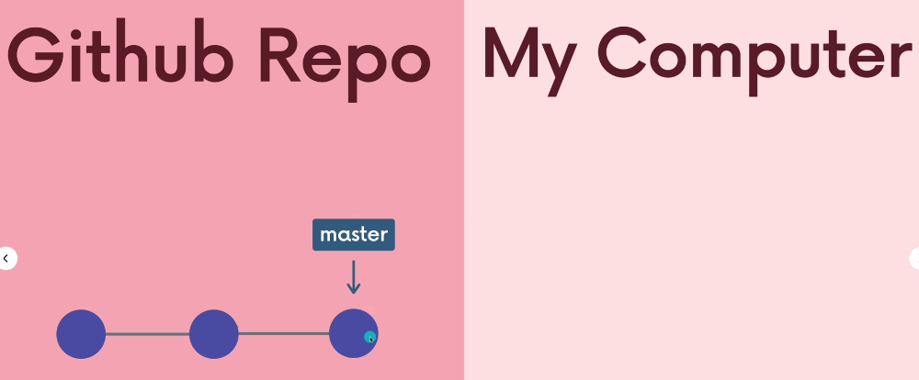

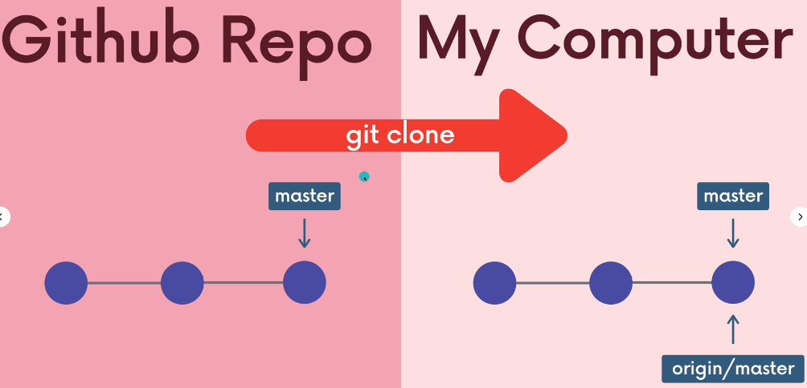

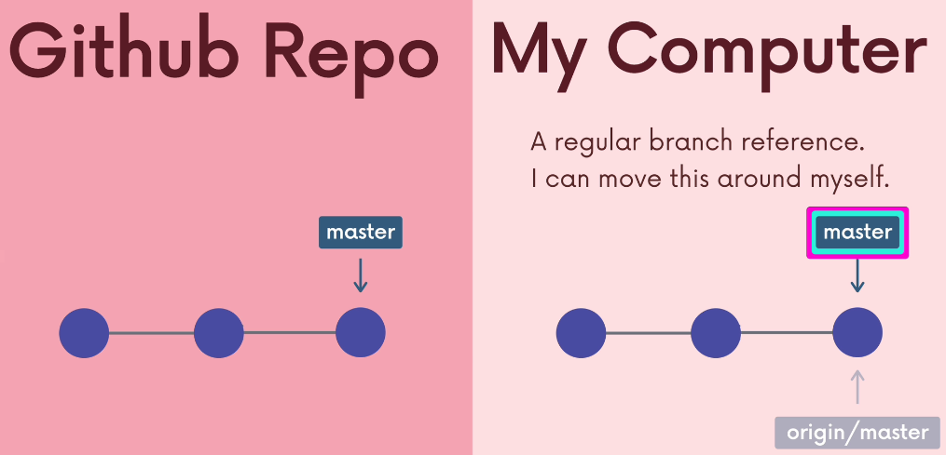

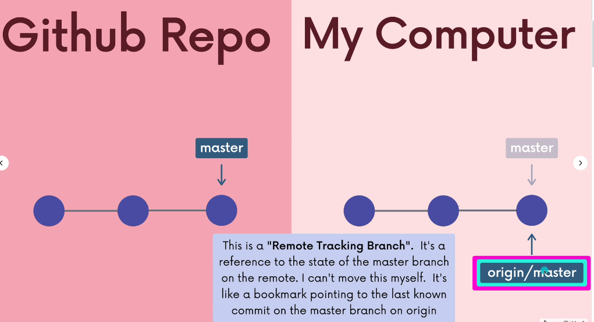

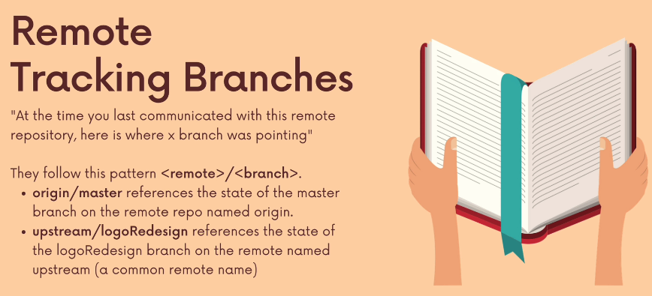

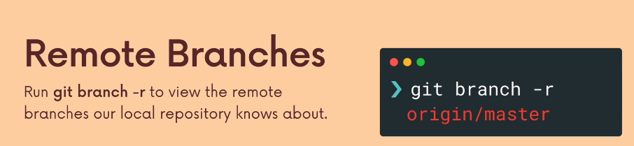

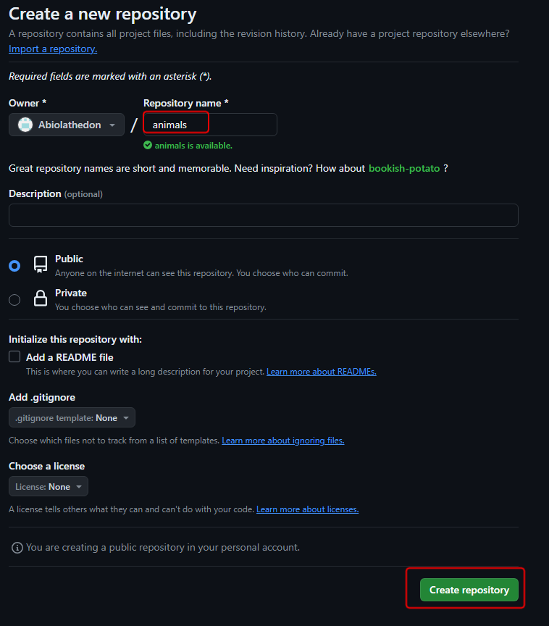

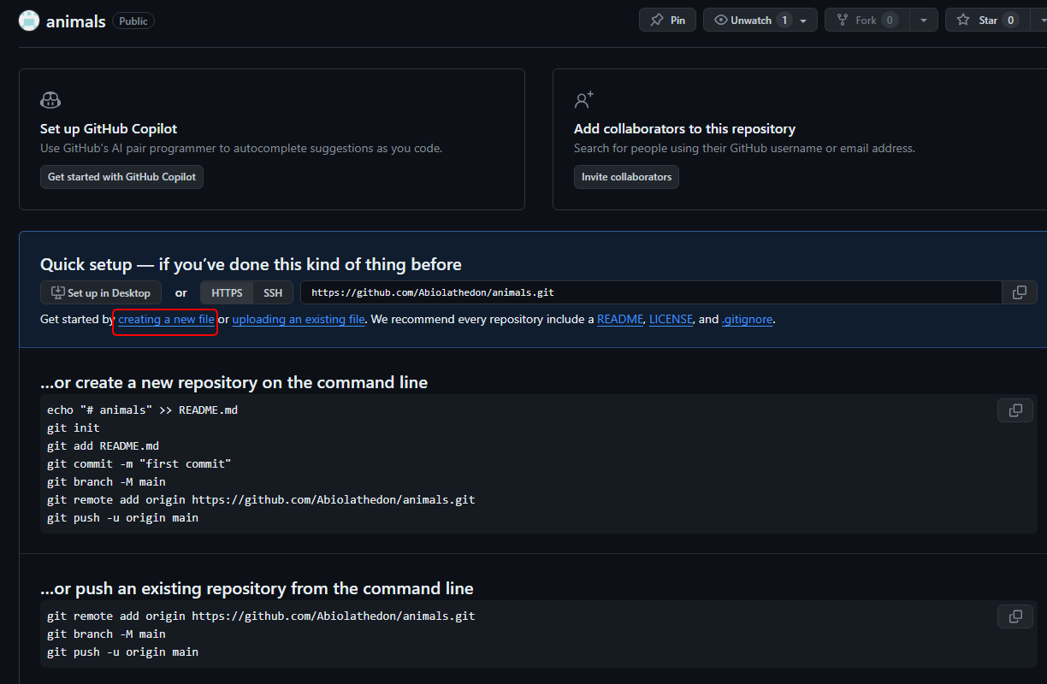

Create a new file

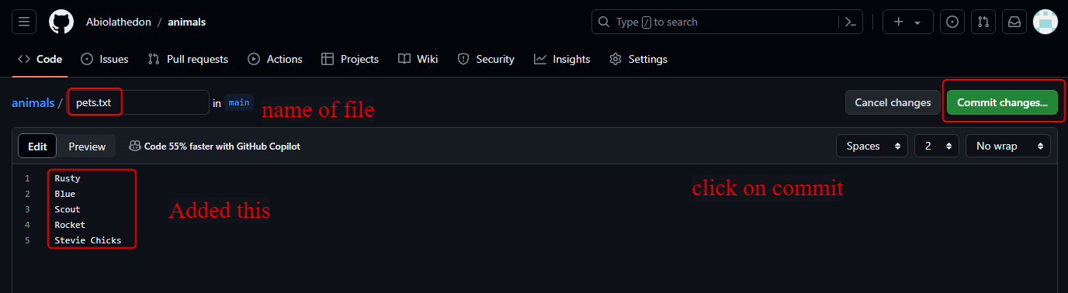

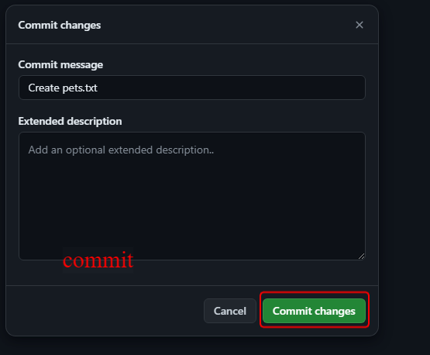

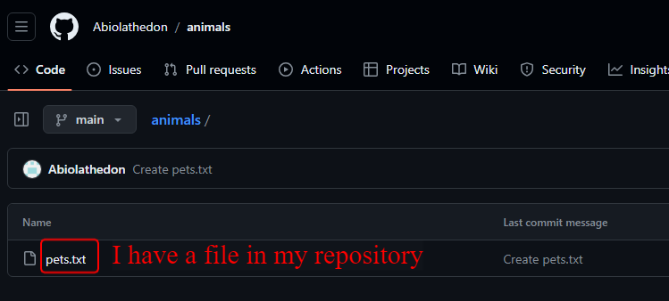

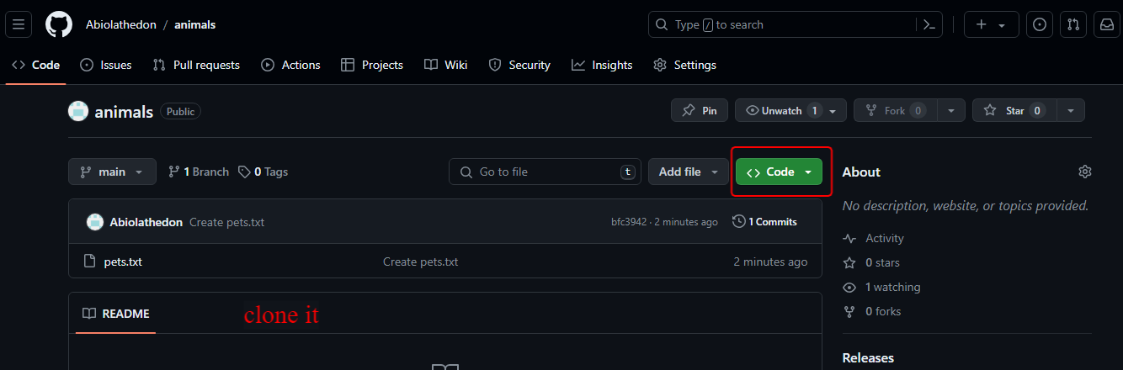

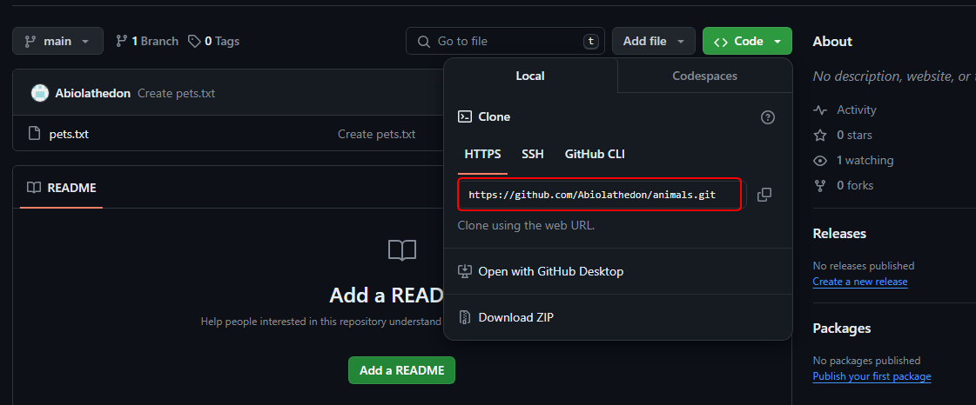

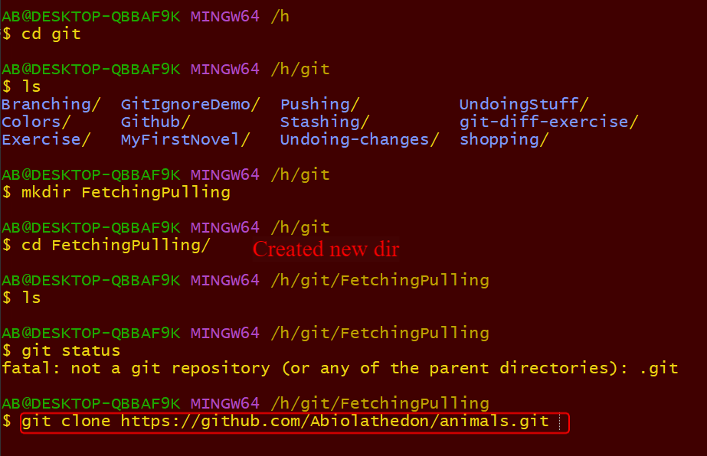

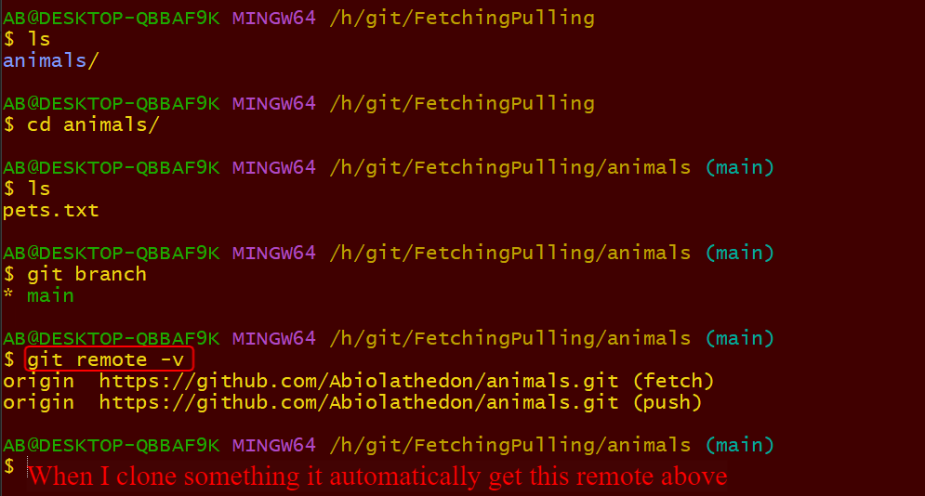

Git set remote tracking on origin

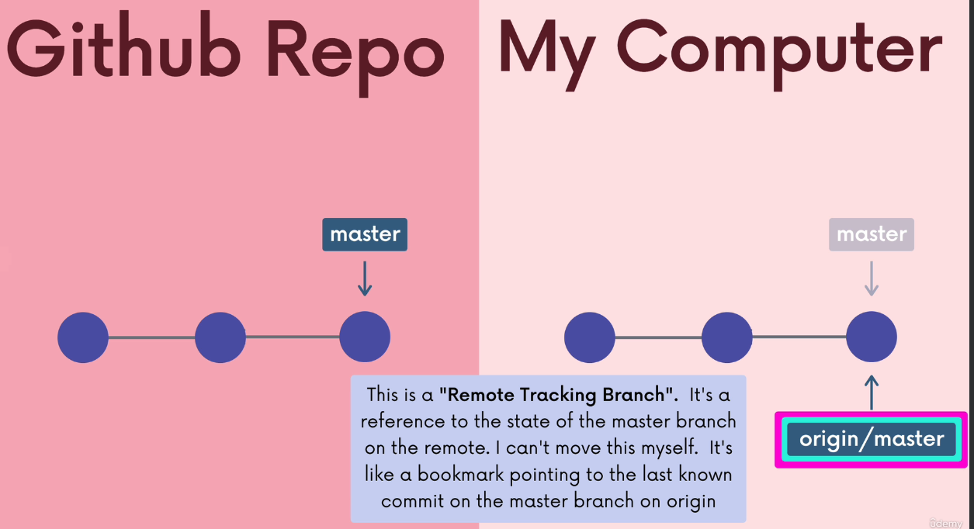

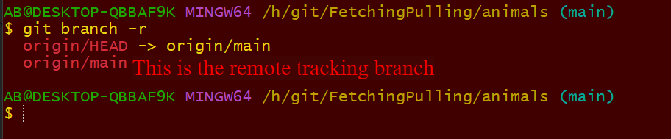

Lesson 109

Checking Out Remote Tracking Branches

28/03/2024

Thursday Ramadan

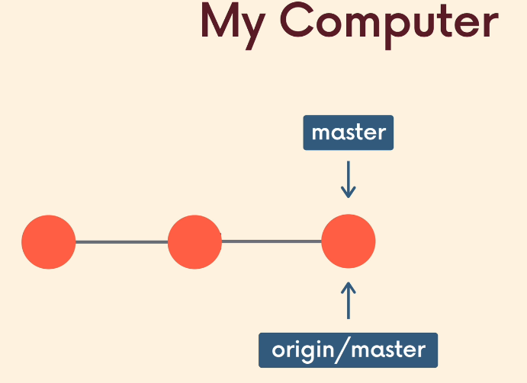

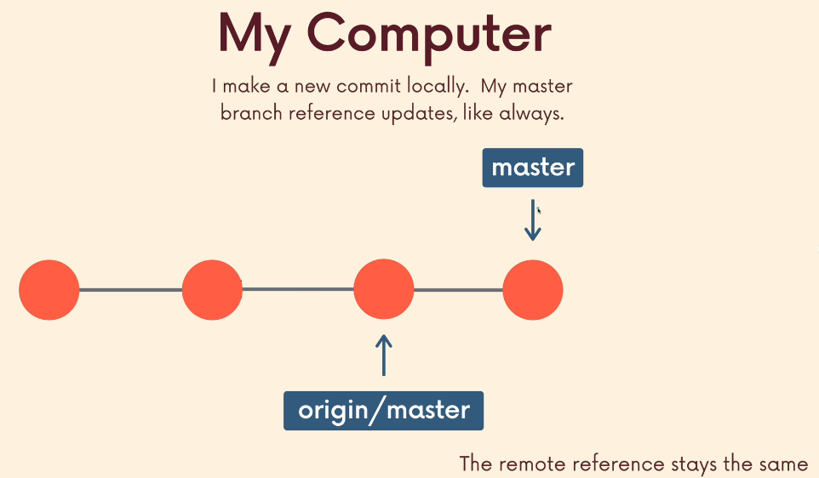

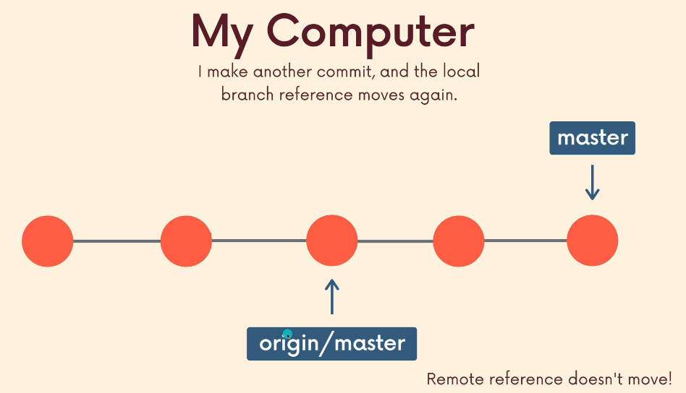

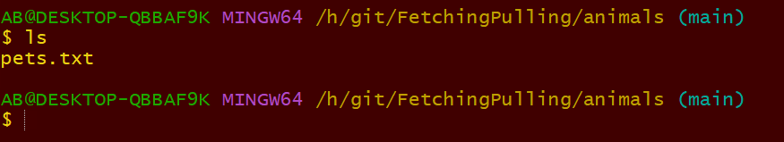

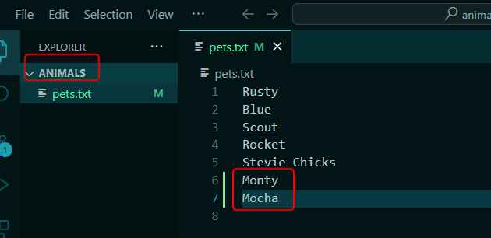

Added those 2

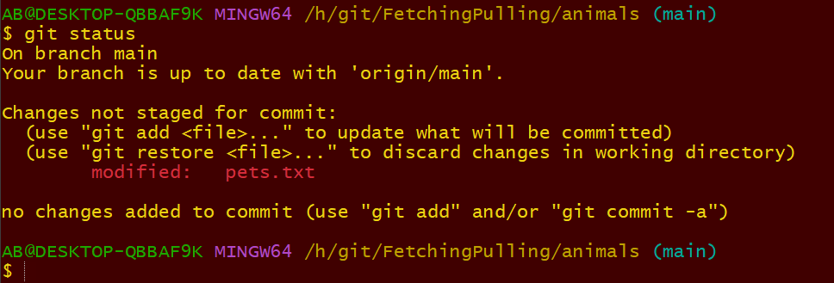

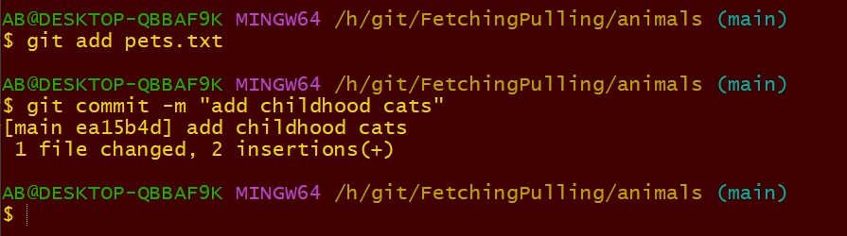

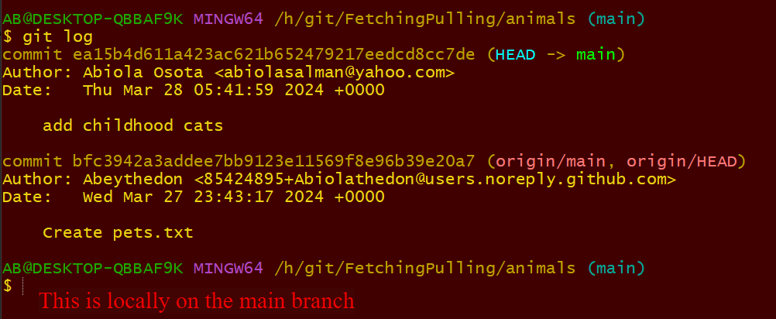

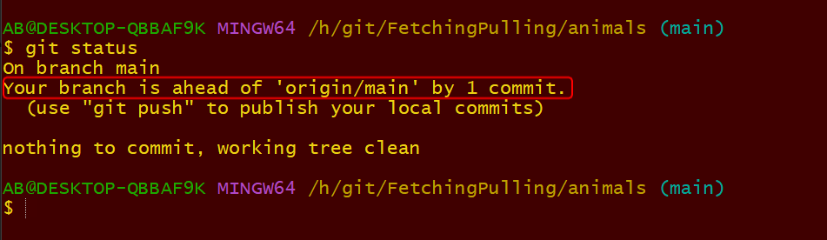

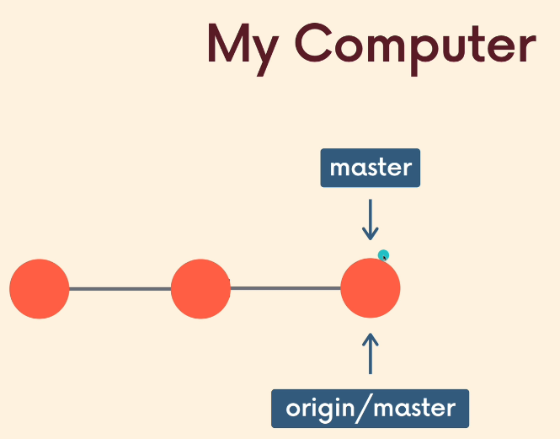

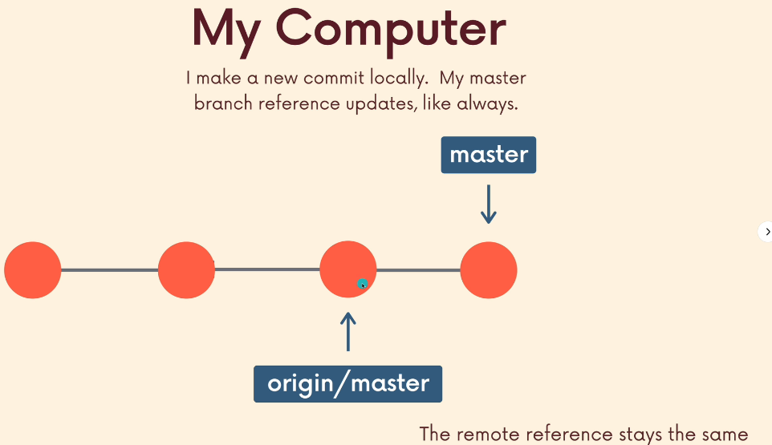

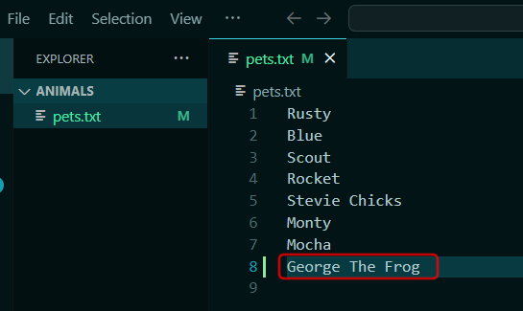

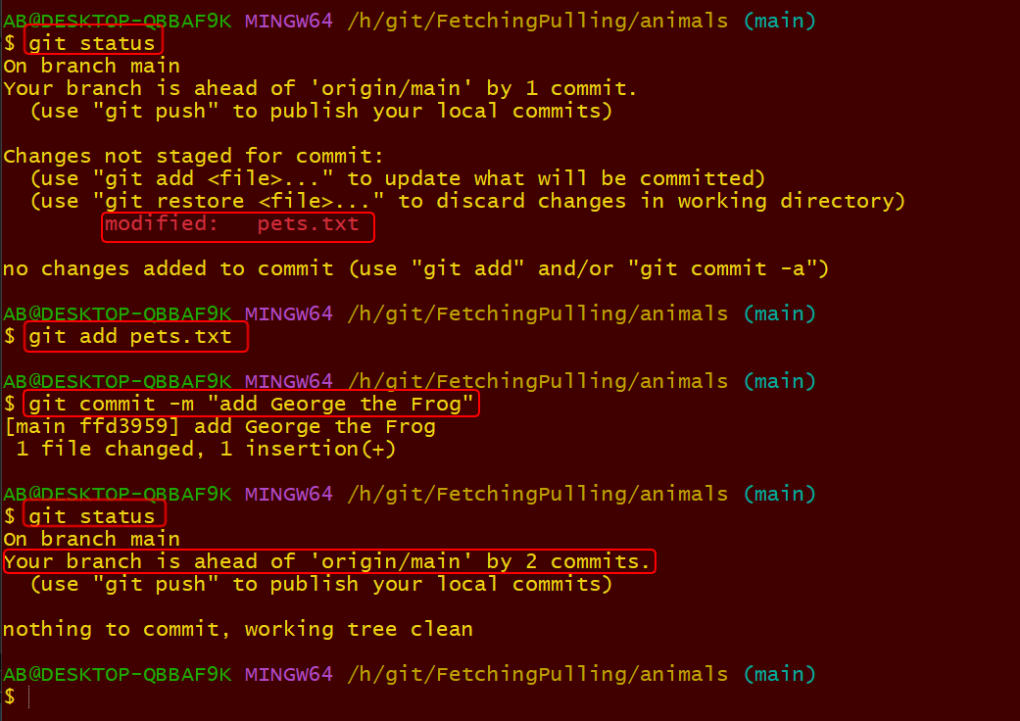

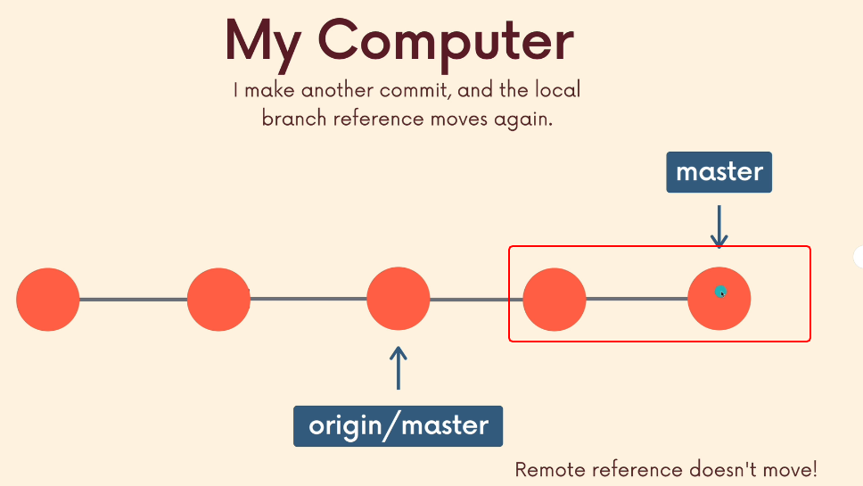

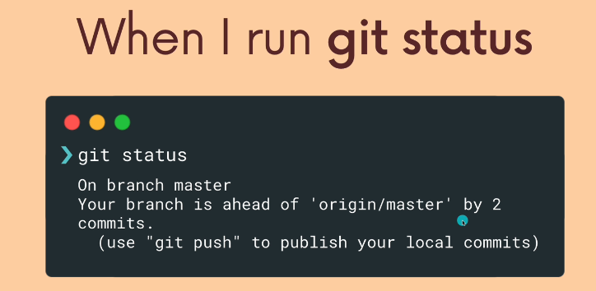

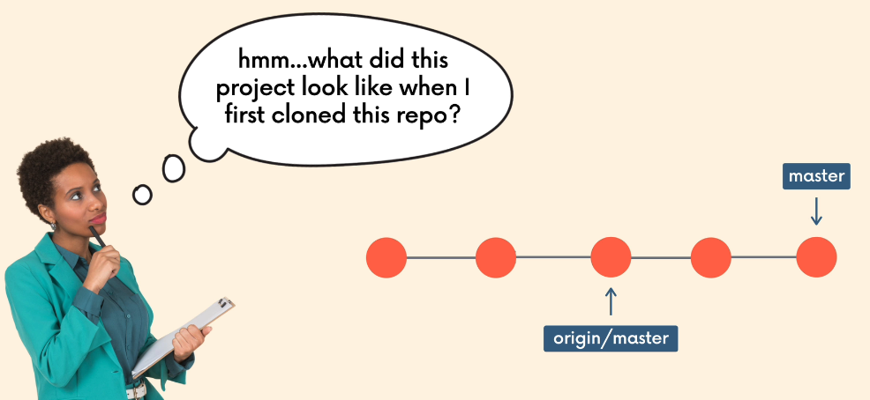

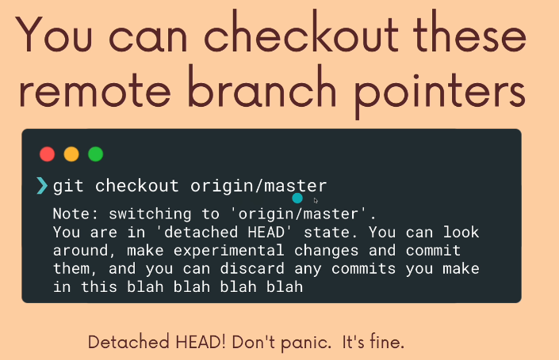

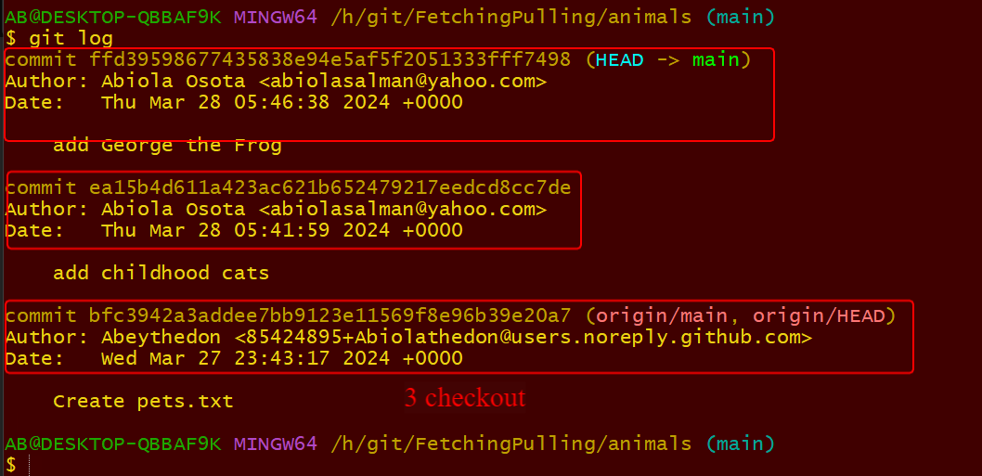

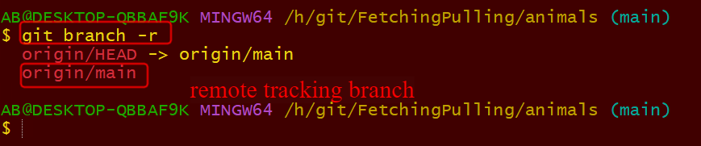

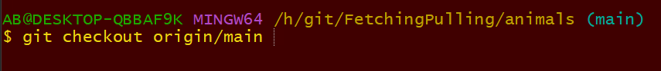

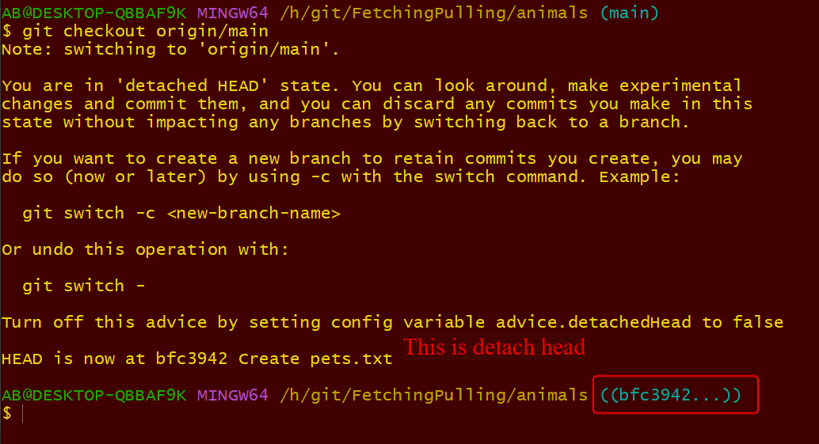

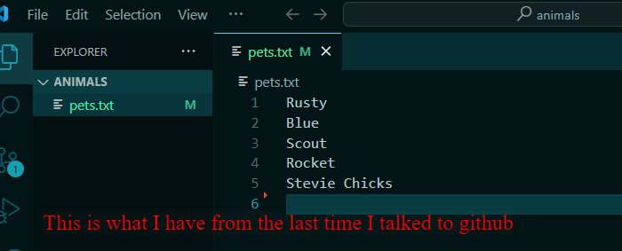

I have moved ahead by 2 commits. I can make branch here or move around. This is just to show you that is where I was since the last time I communicated with github.

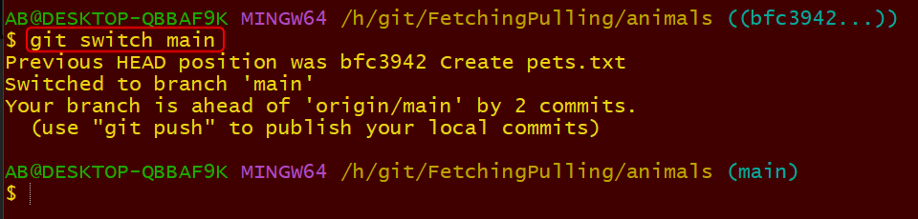

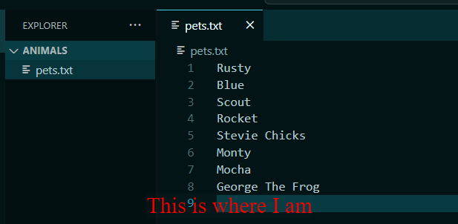

On my local machine.

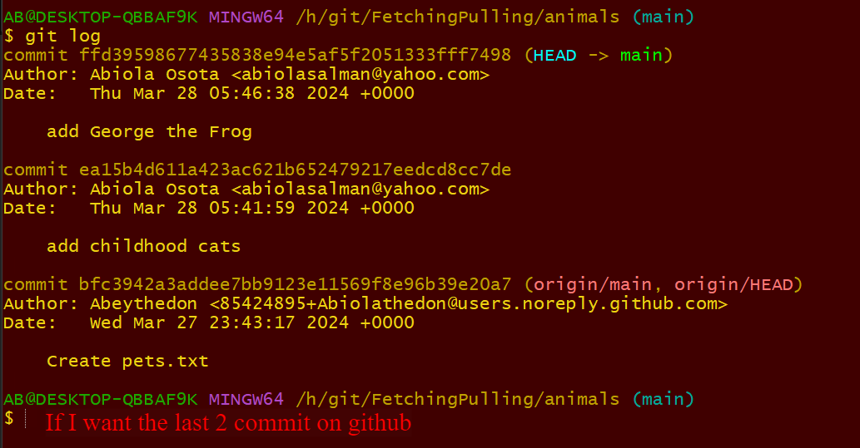



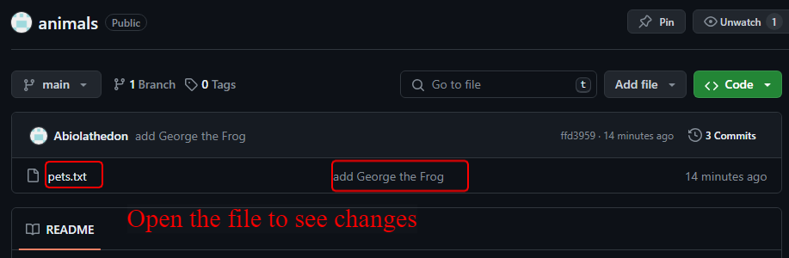

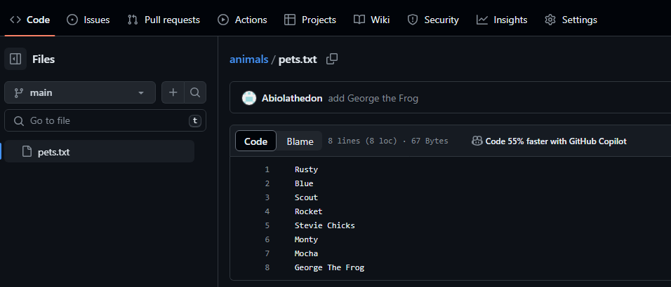

Here is the file.

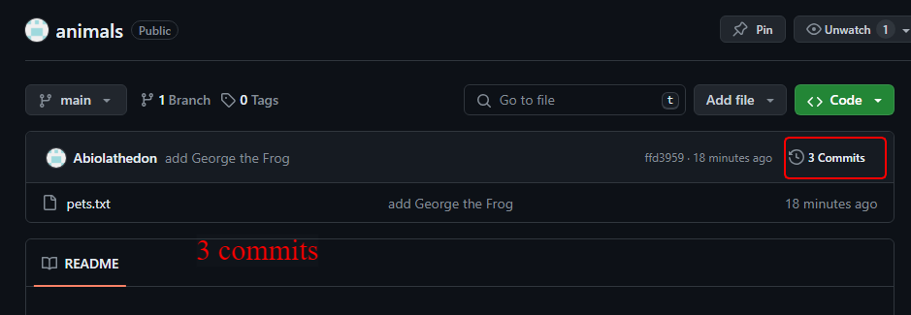

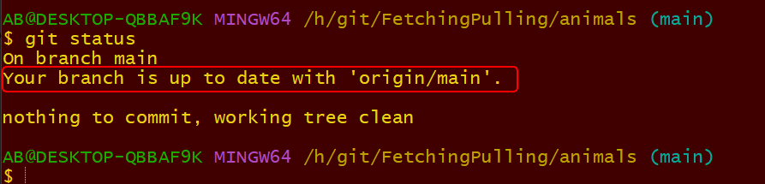

I have communicated with github and I am onto date.

If I commit on main they will defer now.

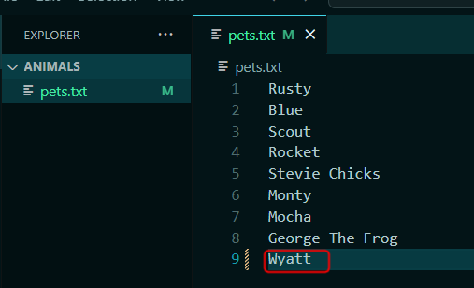

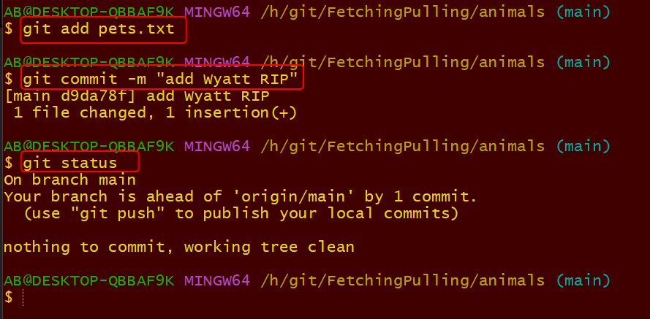

I am ahead of origin/main by 1 commit. I will checkout now

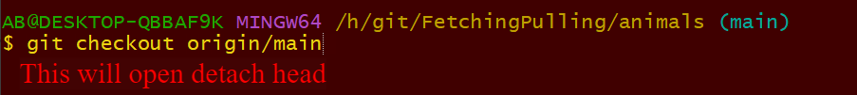

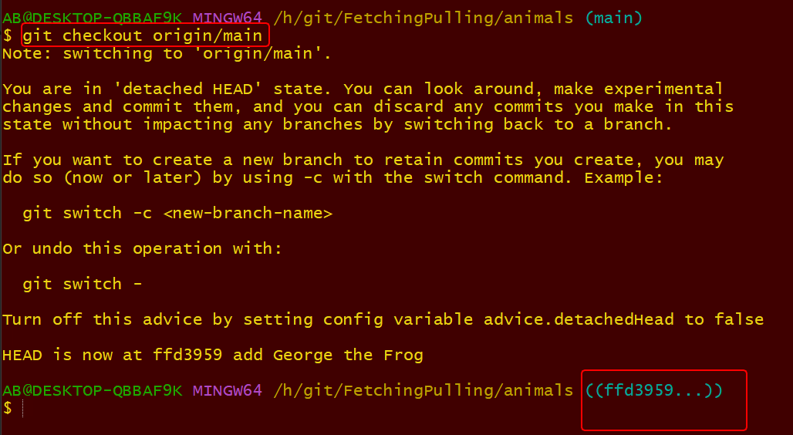

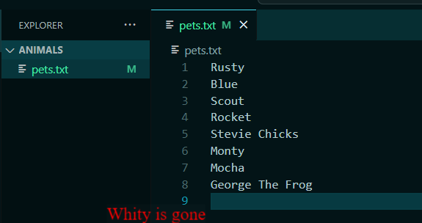

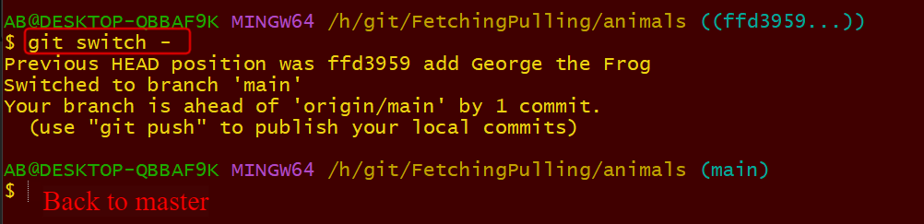



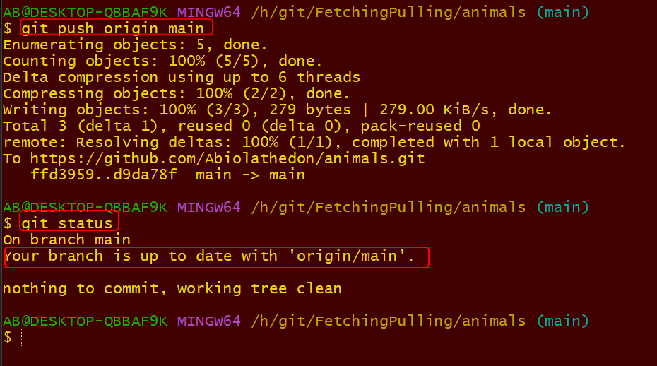

Lesson 110

Working With Remote Branches

<https://github.com/Colt/remote-branches-demo>

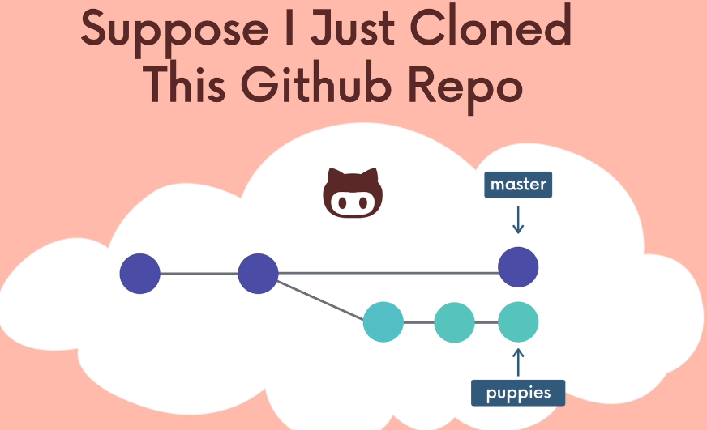

Working with remote branches, that I clone that I want to work on. They have multiple branches on github. How do I work on that repo locally

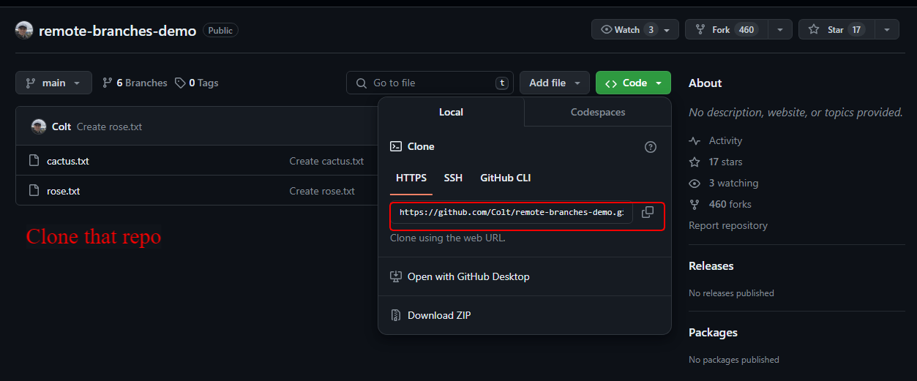

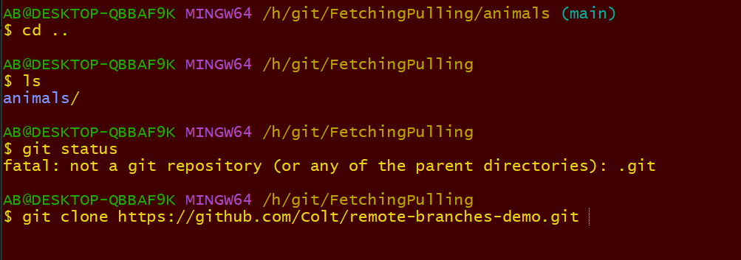

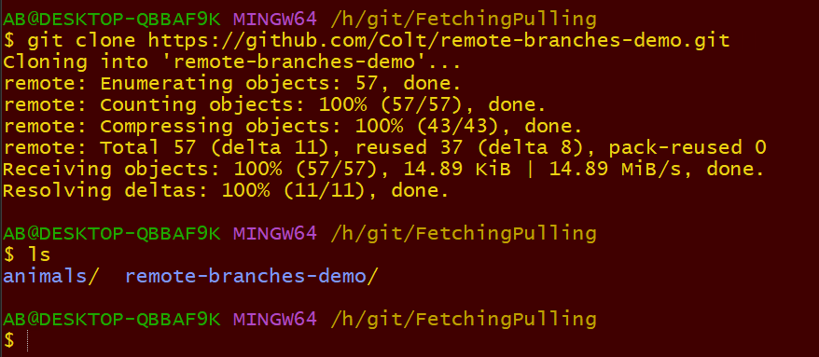

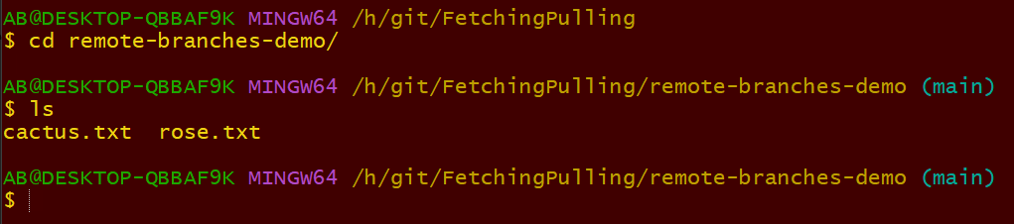

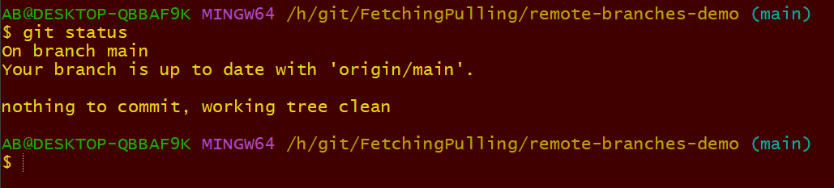

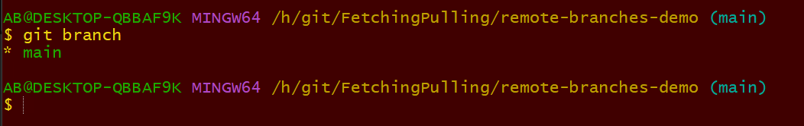

I don’t get other branch. I only get main, How do I get other branches

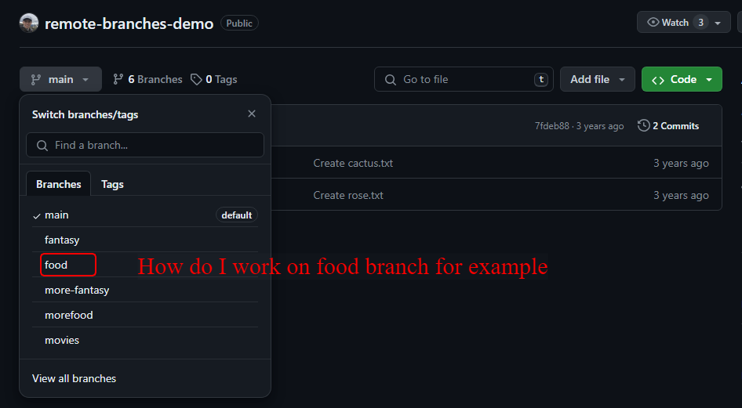

Or how do I work on the rest of the branches.

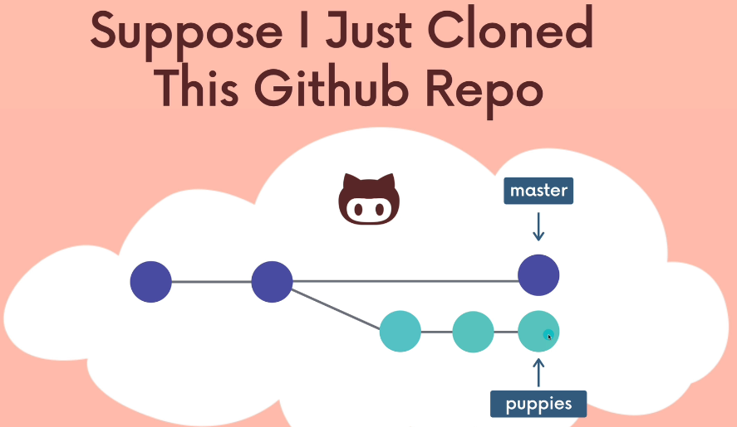

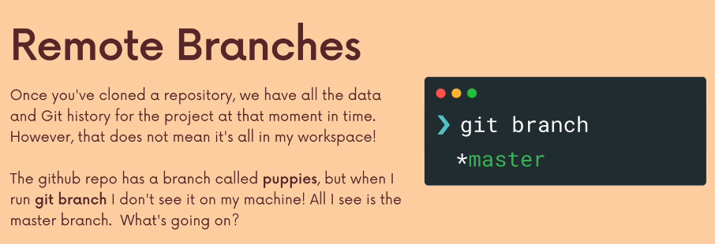

What happened?

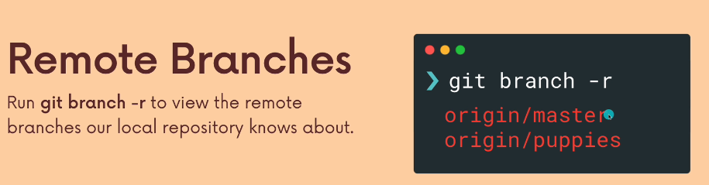

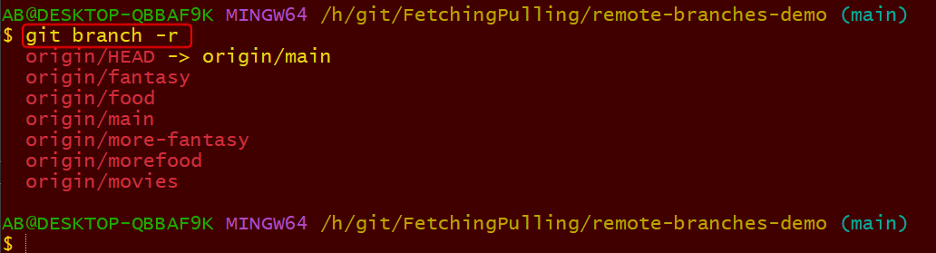

It has remote tracking reference where it can tell me where each one of those reference is. These are like bookmark. My repo knows about them but when I run the branch I don’t see full flesh of the branches. How do I make that happen

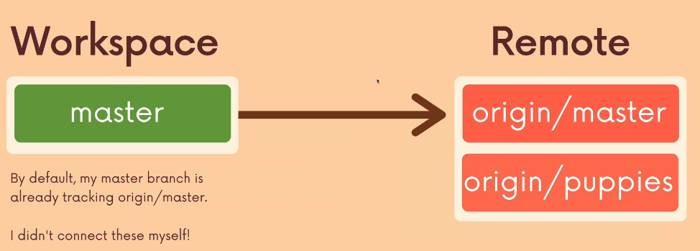

When I clone a repo, the master branch automatically tracking the remote master tracking. I have other branches that are remotely connected.

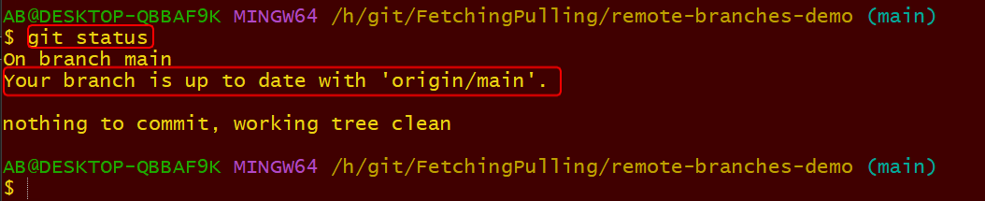

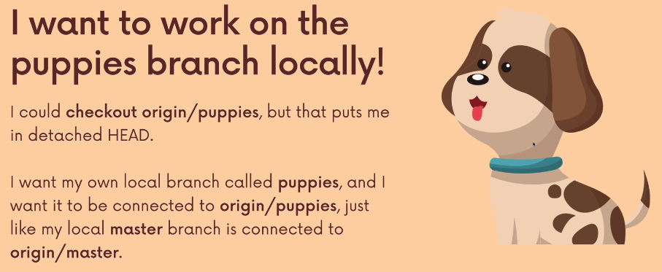

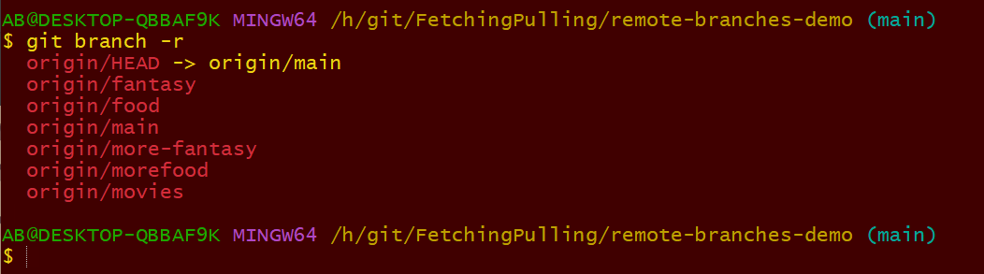



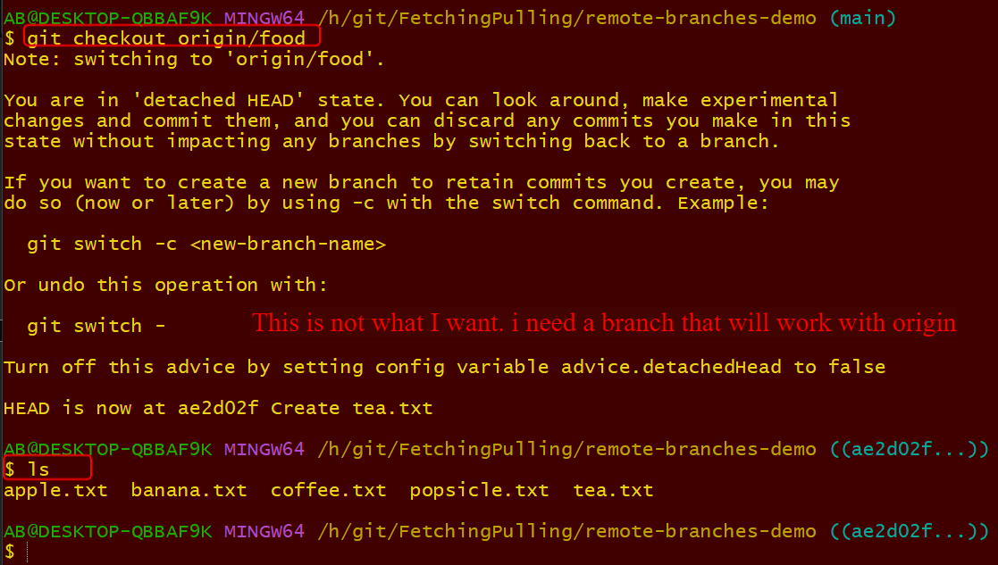

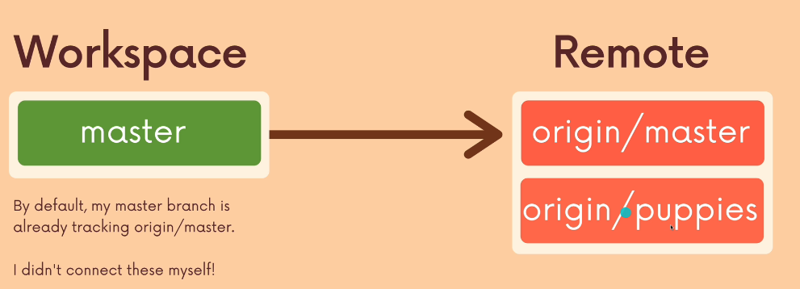

I want to work on branch that is connected to origin and /puppies. Rather than checkingout

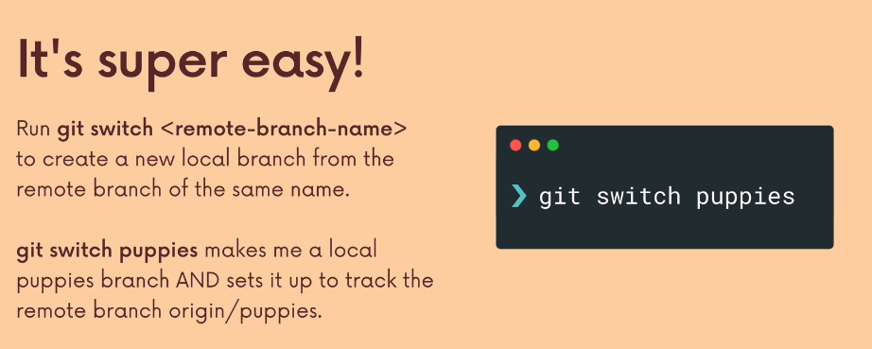

If I make git switch puppies it will make me a remote file that will be tracking origin/ puppies automatically

Date Ramadan Friday 29th/03/2024

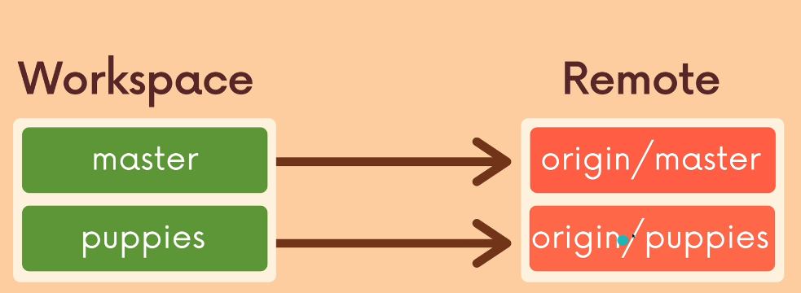

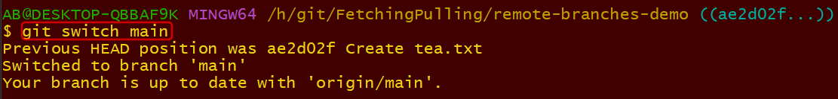

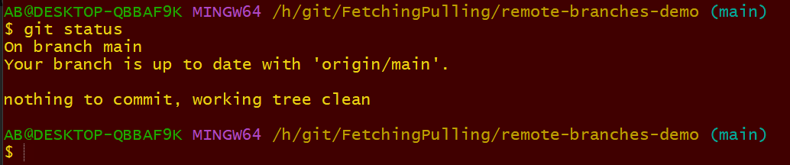

The main is automatically connected. I want to switch now

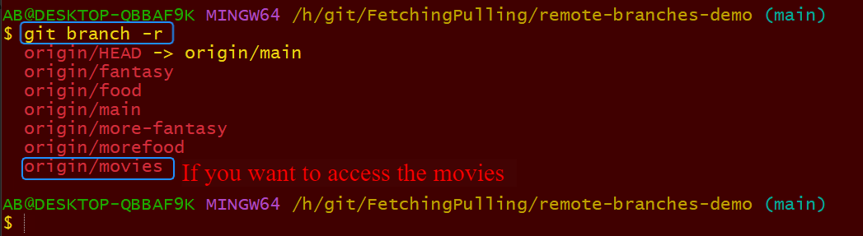

This is one of this remote branch that I don’t have movies.

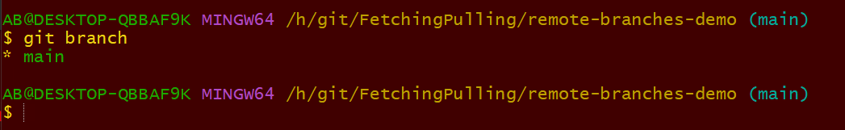

This is what I have for now

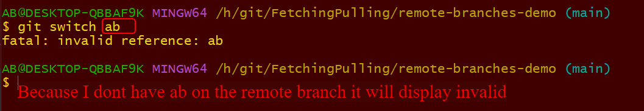

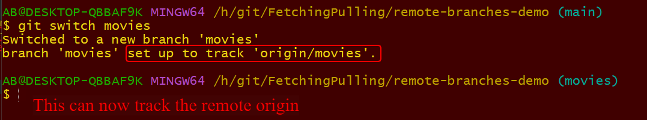

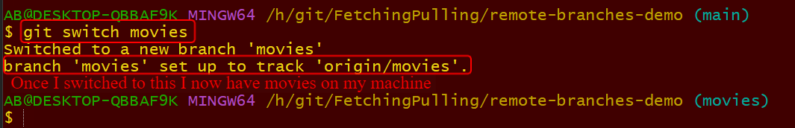

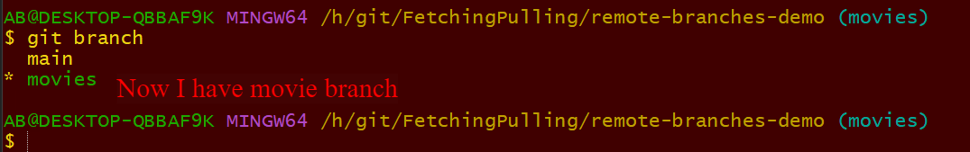

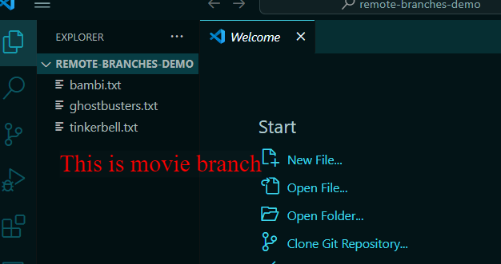

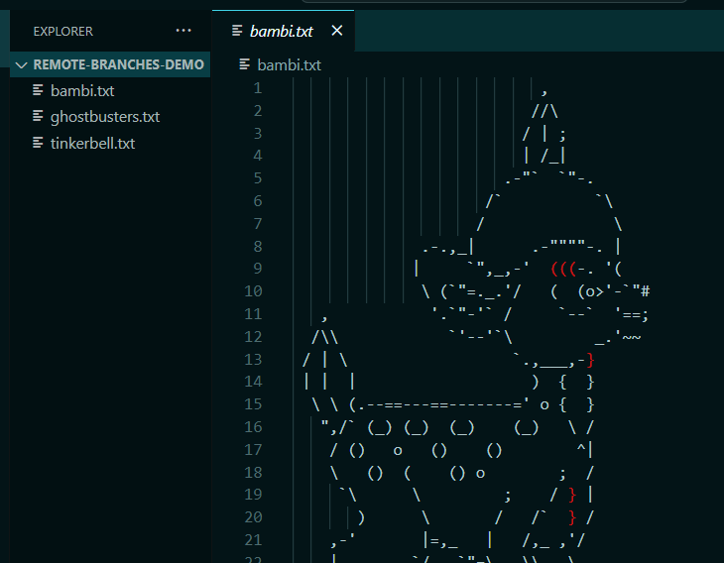

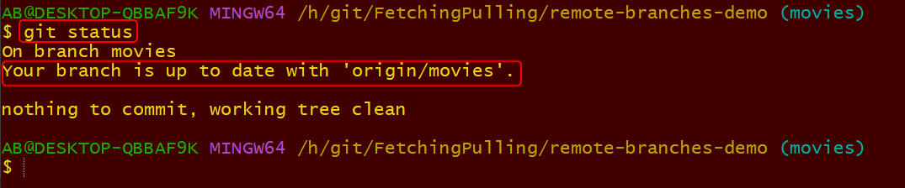

The origin/movies the branch movies is now connected with tracking

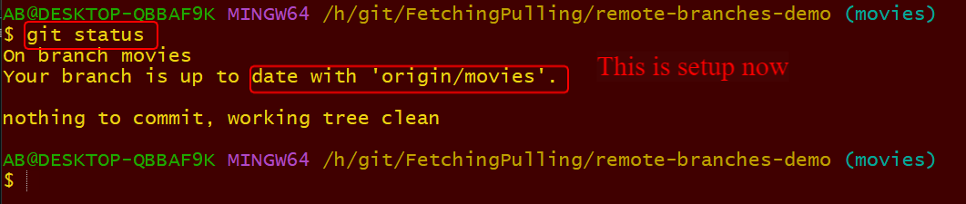

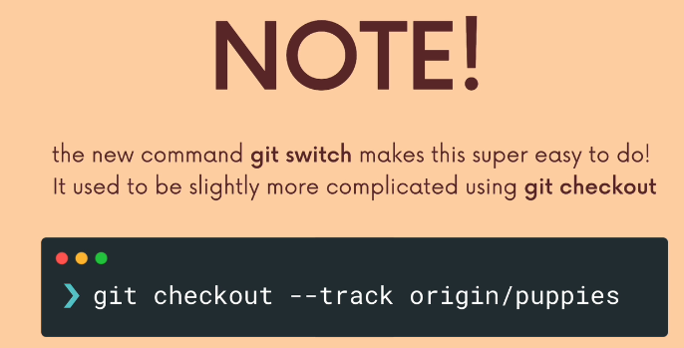

If you want to work on a branch that is on github repo that you don’t have it locally and you want on it locally. Use git switch and the name of the branch.



I want to check the fantasy out

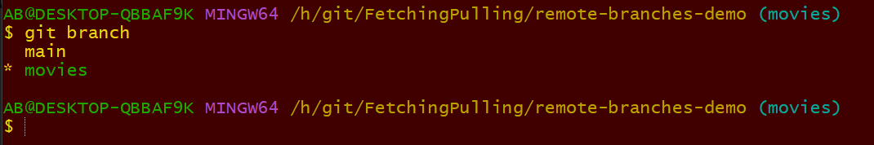

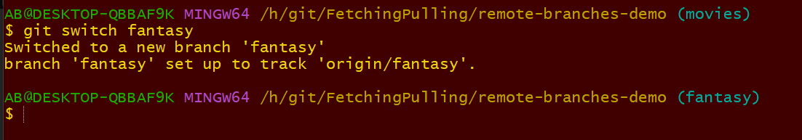

**It set**up for tracking remote

**Switch t**o fantasy

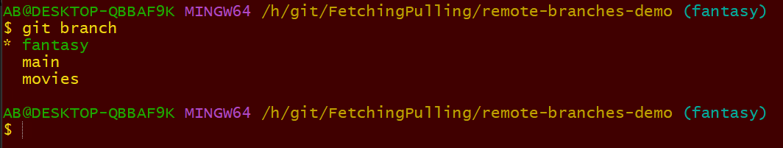

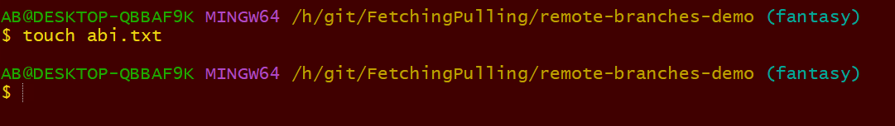

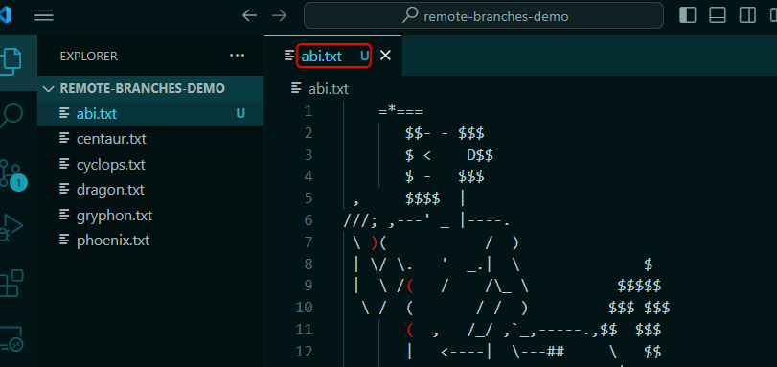

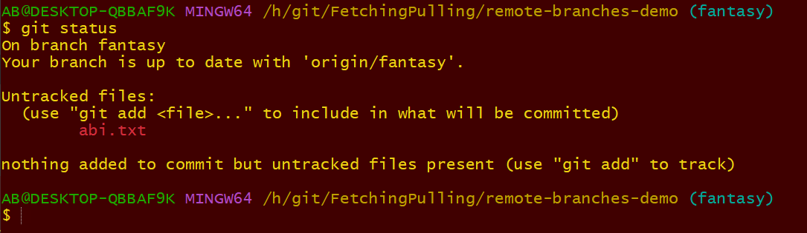

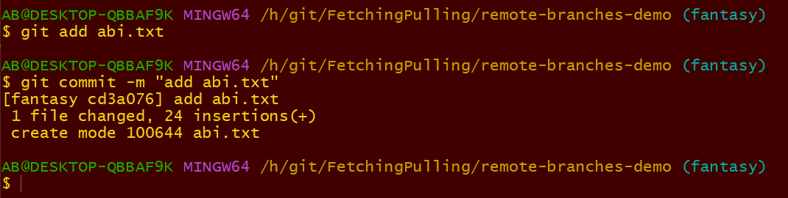

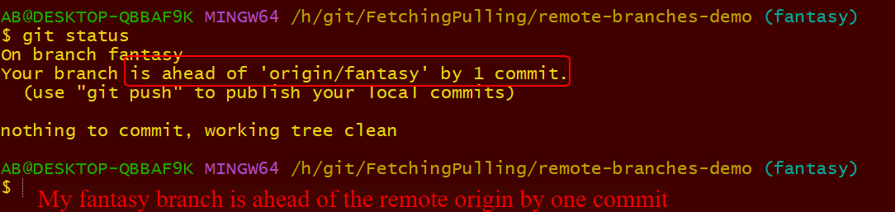

Meaning I have work on this machine that I can push up

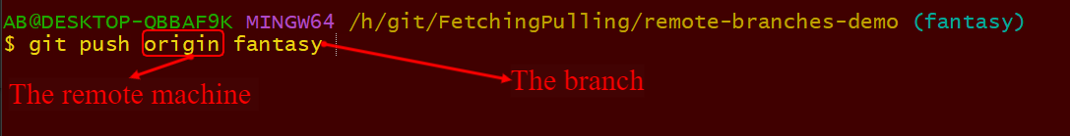

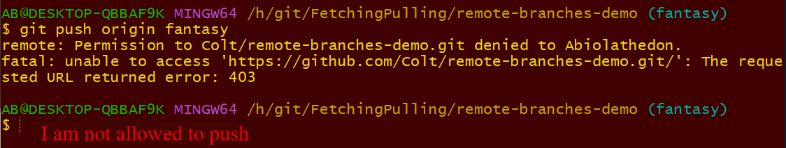

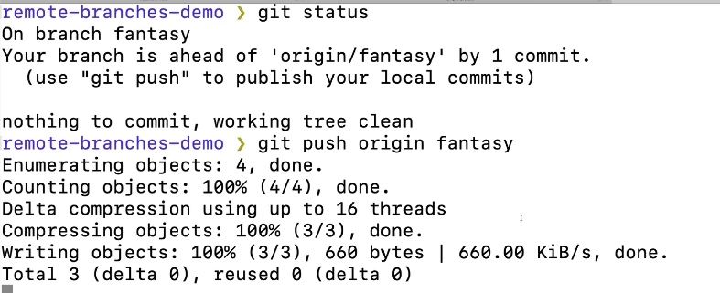

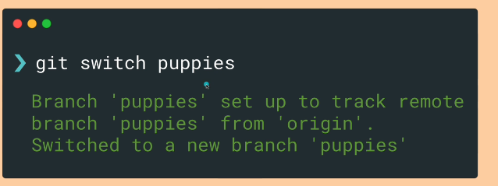

The lecture is about if you don’t have the branch on your system yet and you use the name correctly. Git will make the branch on your local machine.

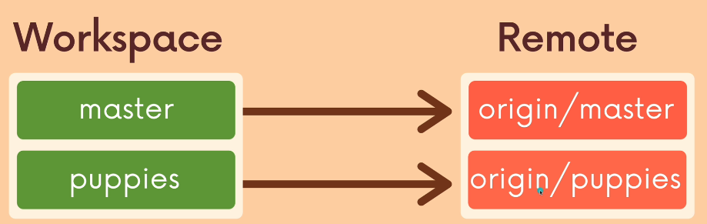

Lesson 111

Fetch: The Basics

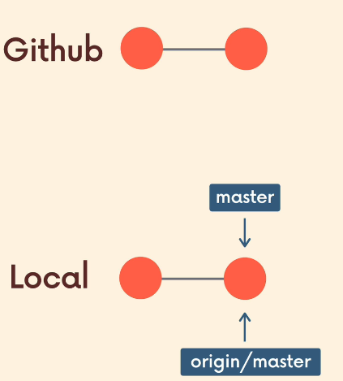

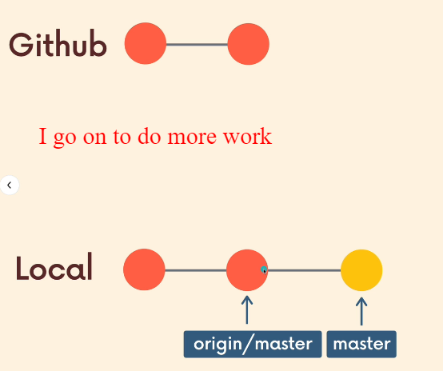

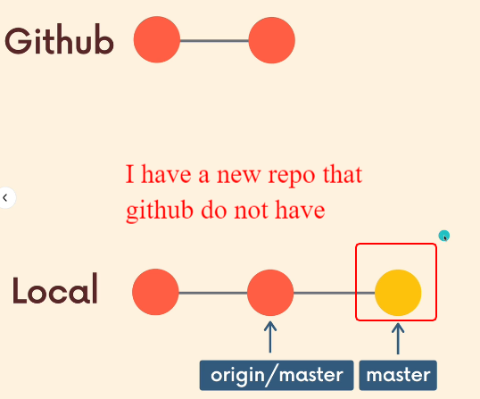

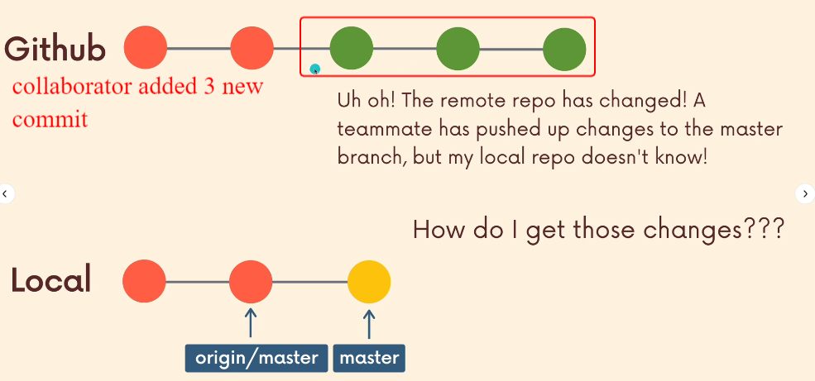

I don’t have the new commits because I am on local, how do I go about.

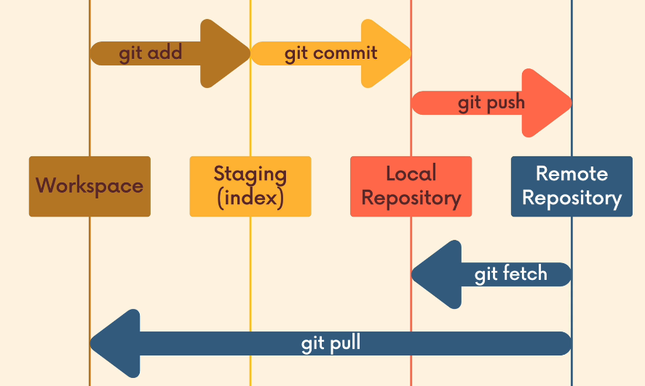

The git fetch and pull are command that are used to pull changes from repository. Fetching will take remote changes and will bring them down to the local repository.

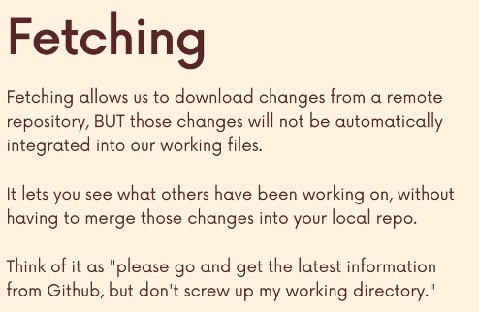

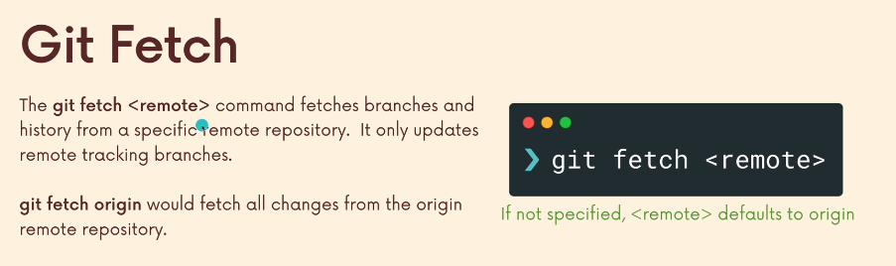

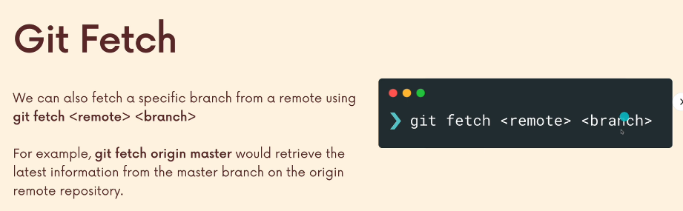

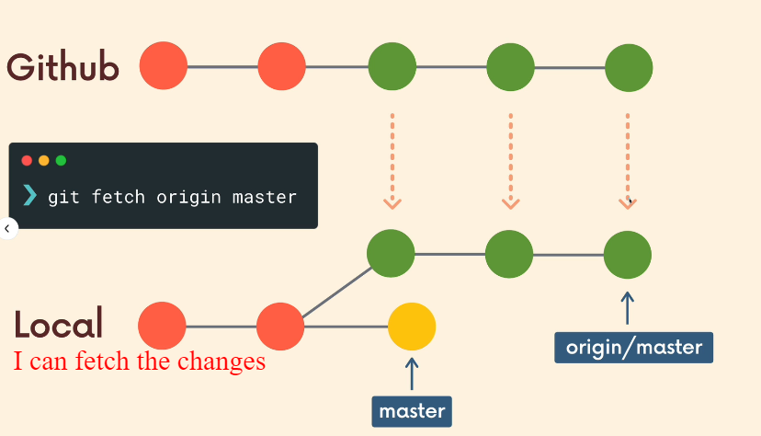

From origin master I have access to the changes and I can see the changes, but my master slide as not changed in anyway.

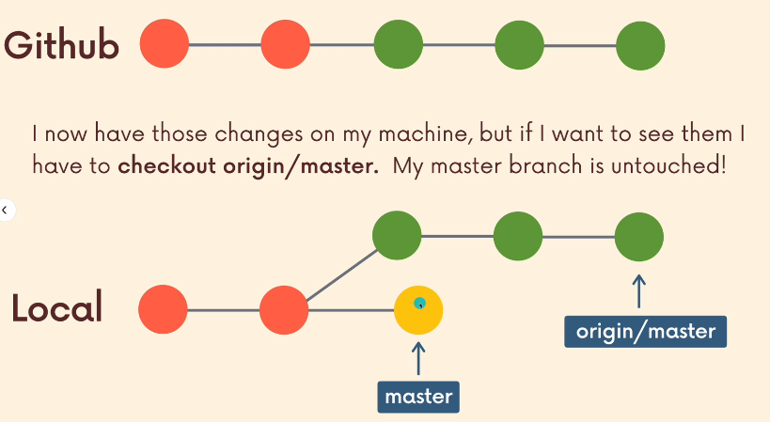

Lesson 112

Demonstrating Git Fetch

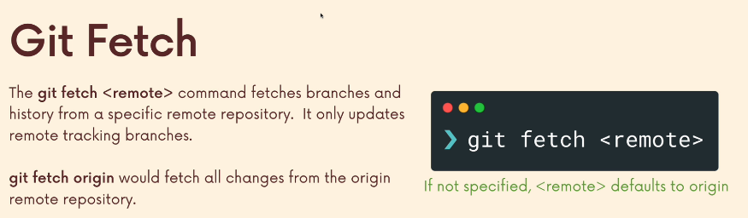

This is the scenario. I have several changes in different branch on github, usually someone who have push their changes here I don’t have someone that does that but will pretend

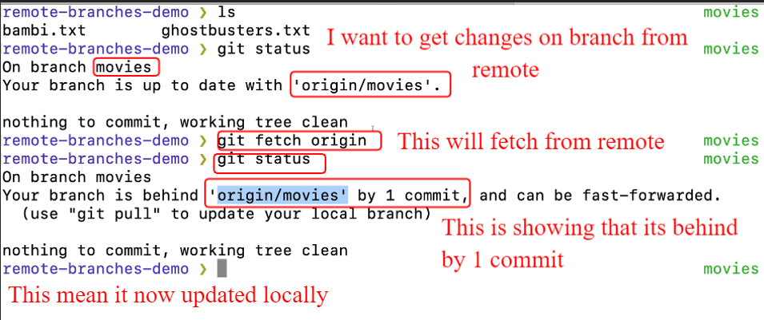

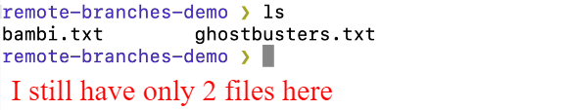

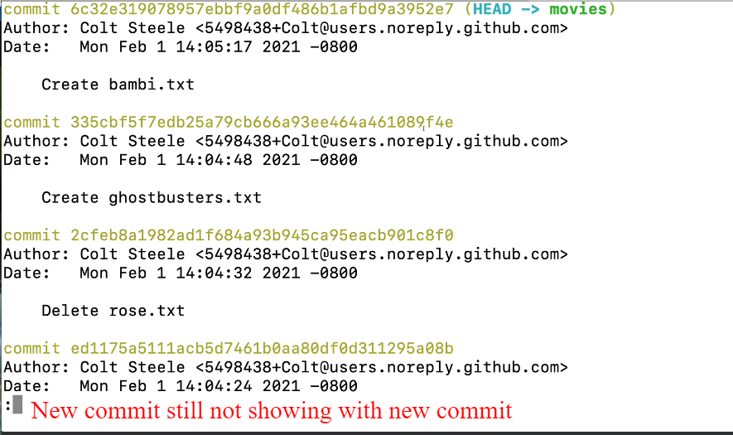

Nothing has changed inside my working dir

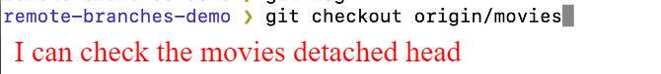

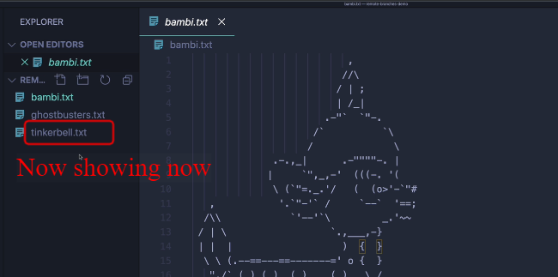

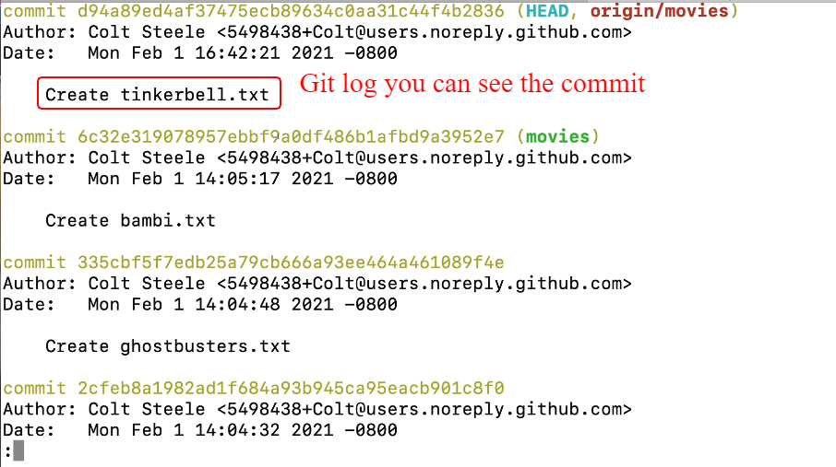

You can create a new branch from here if you want

But I will talk about pull if you want the work to be available in your working directory.

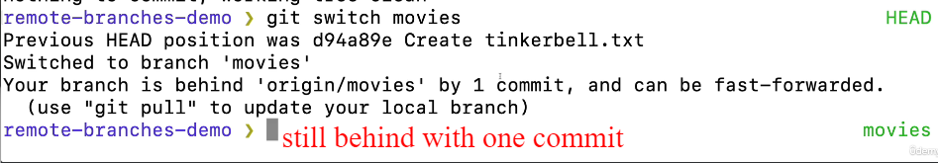

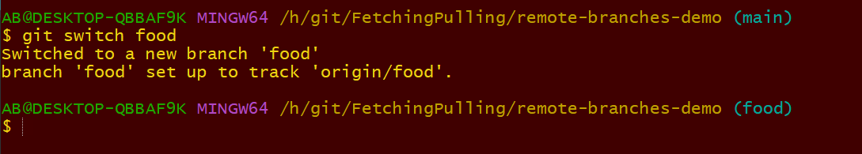

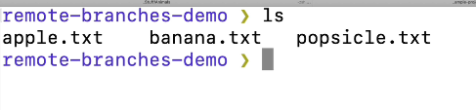

Here are the files inside this branch.

He added another file inside the food branch. You added the file and commit

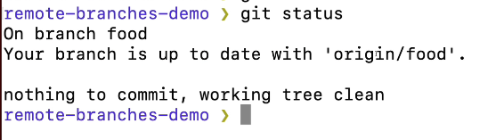

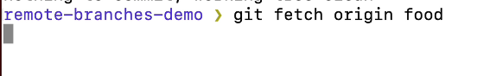

You can also fetch git update.

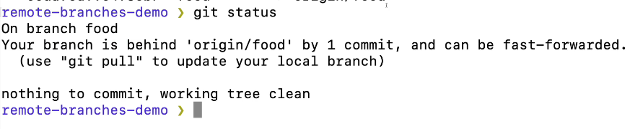

The branch is behind the origin /food by 1 commit.

I added a new branch from github and its called morefood

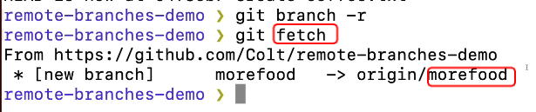

This is pointing to origin/morefood

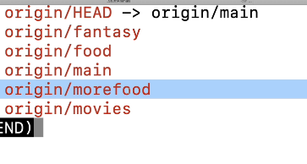

Once you check the branches, local repo knows about it.

Lesson 113

Git Pull: The Basics

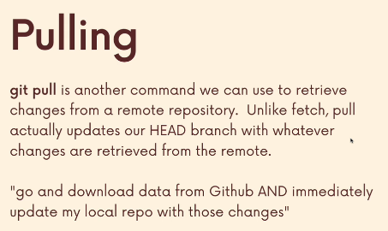

This will download and update my working directory.

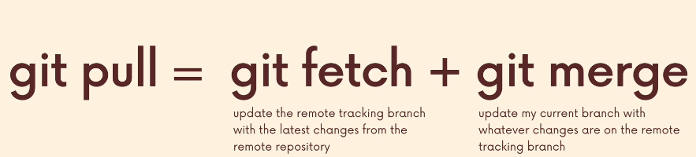

This does multiple job.

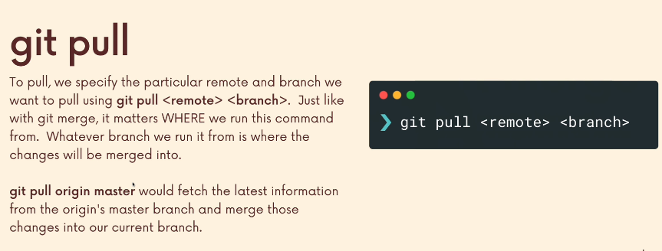

Very important branch im on that is where it will be pull down and merge it to



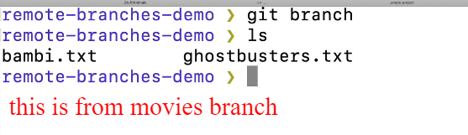

Remember I am on movie branch.

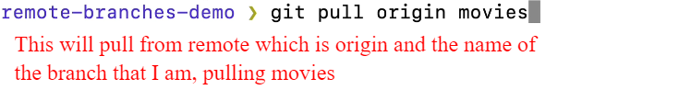

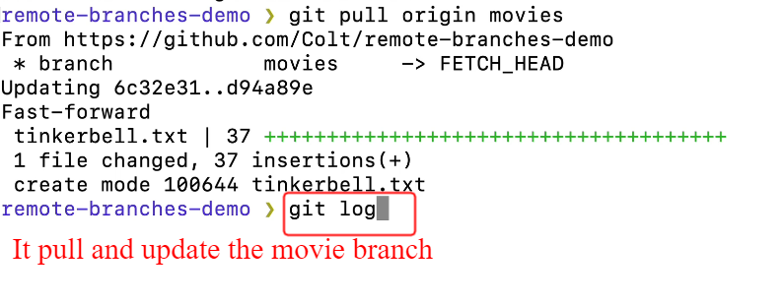

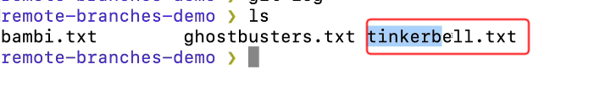

Now I have the file.

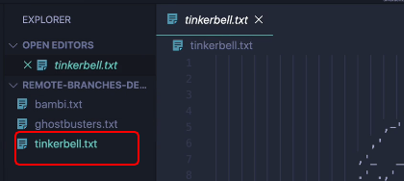

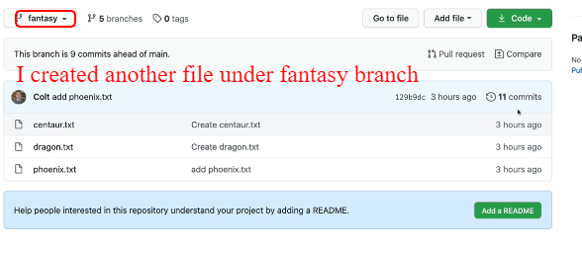

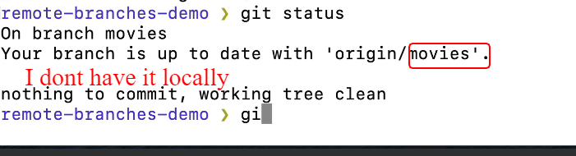

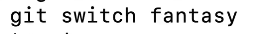

Switch to fantasy.

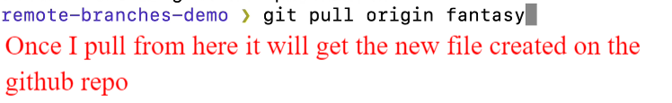

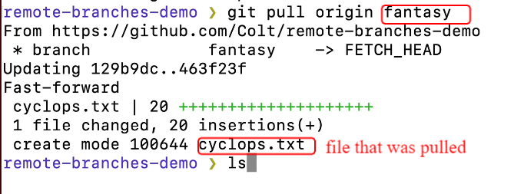

Lesson 114

Pull & Merge Conflicts

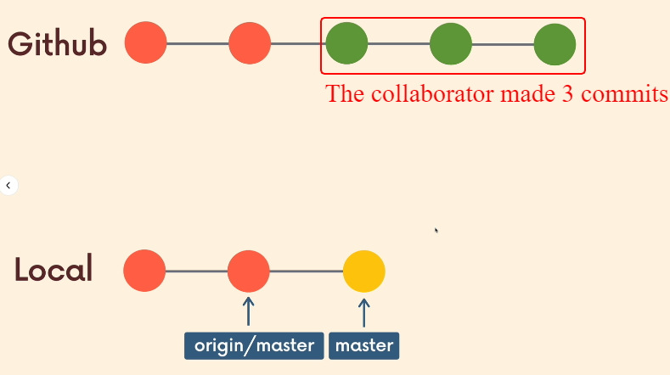

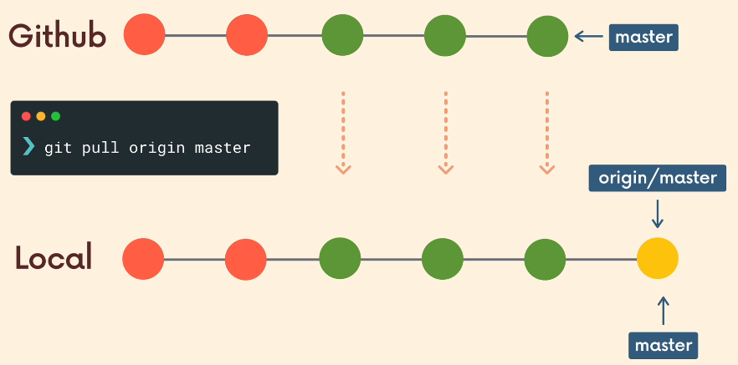

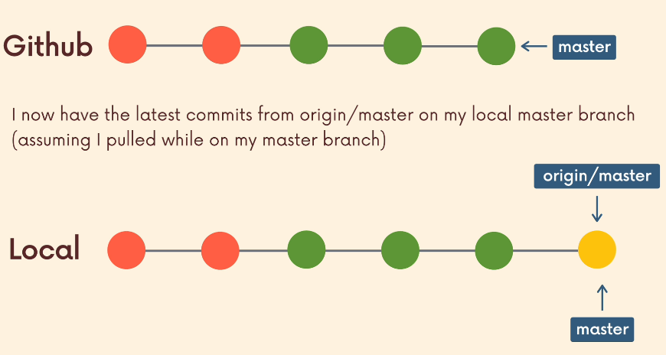

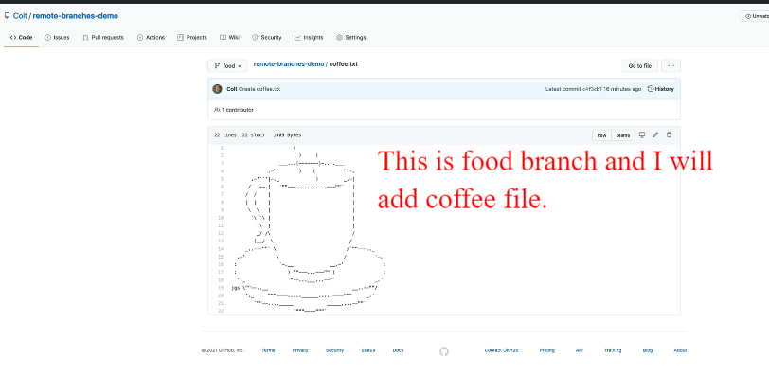

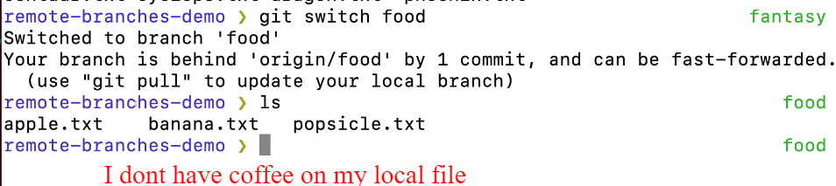

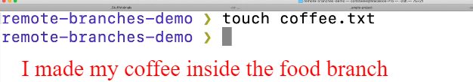

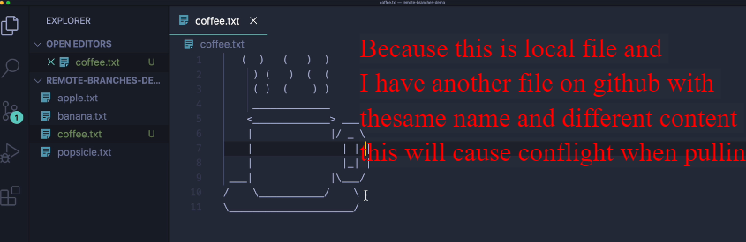

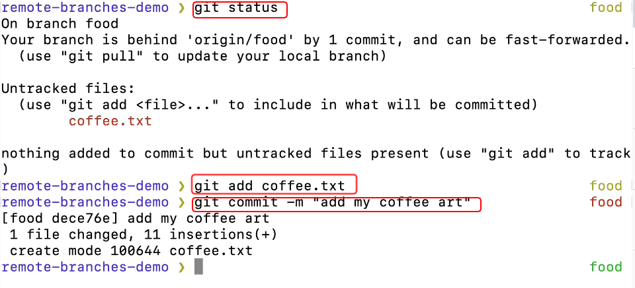

As a good practise always pull down and see if there is any changes.

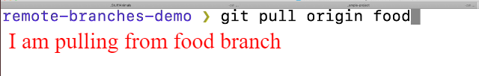

Remember I have a commit that is on github but not on my machine, and I have a commit on my machine not on github.

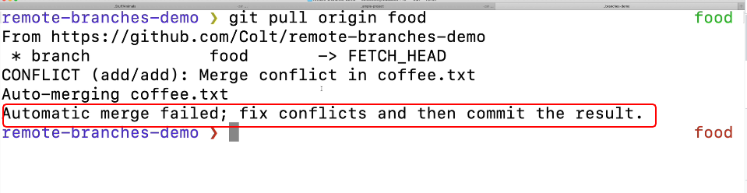

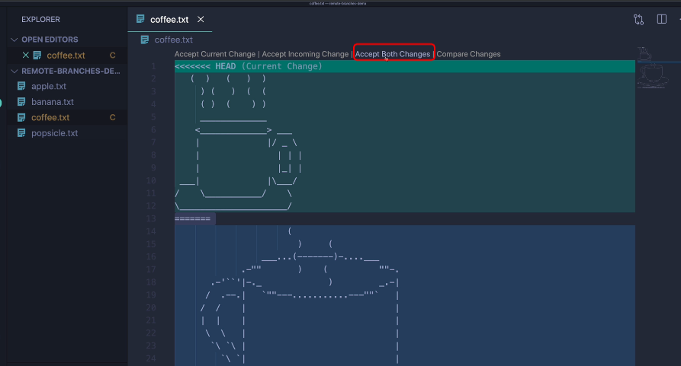

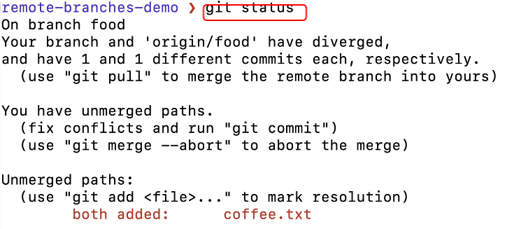

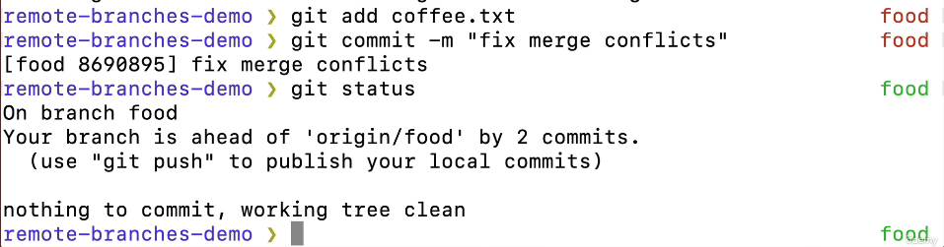

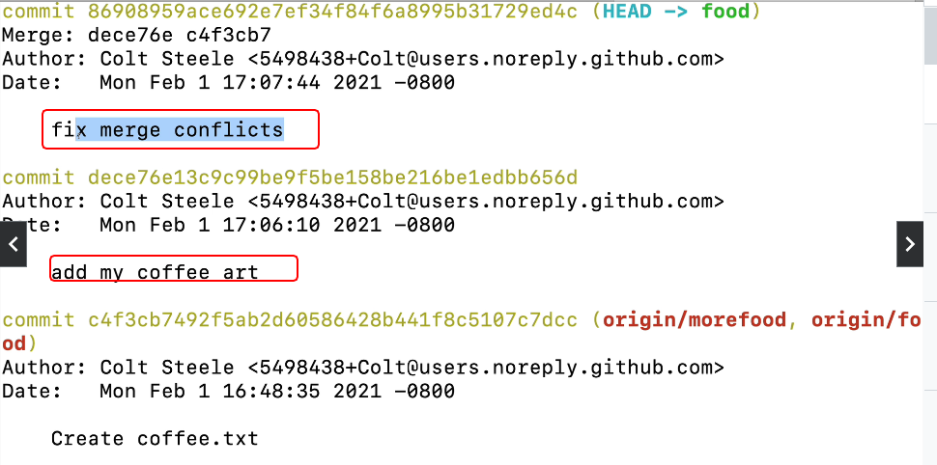

I have pulled and resolve the conflicts. Now that is resolve I can push back to github.

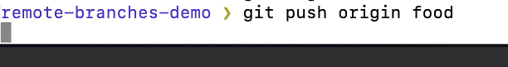

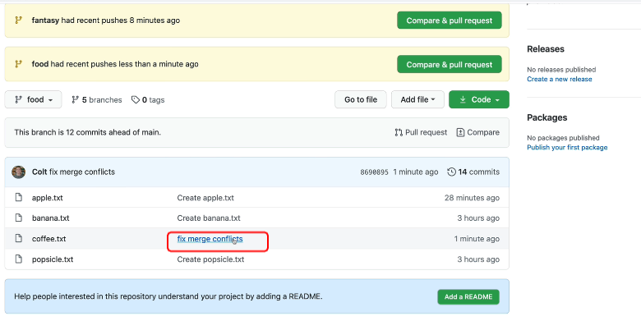

Lesson115

A shorter Syntax for Git Pull?

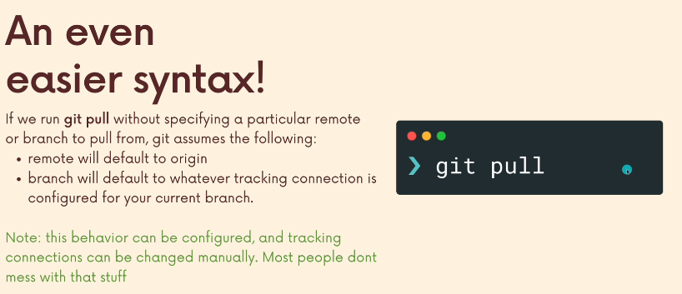

Even if you don’t specify the remote of origin, git pull will default to origin when you pull.

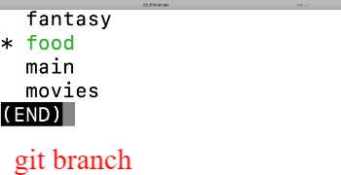

I want the latest on food on github.

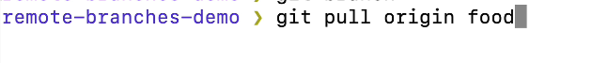

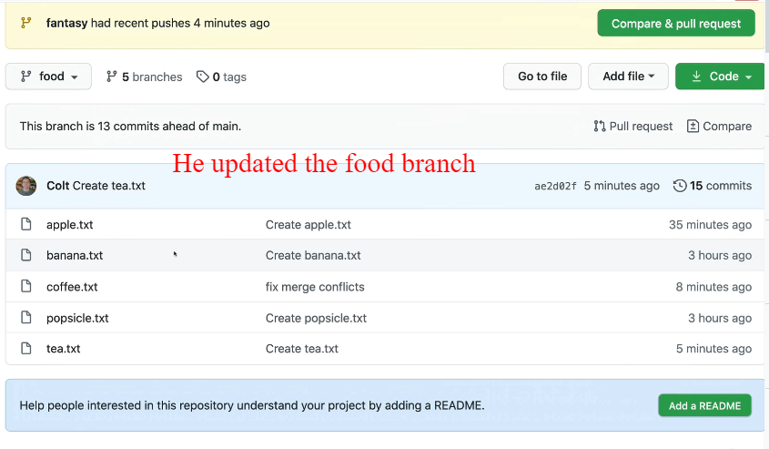

By adding tea file. I do not have that locally

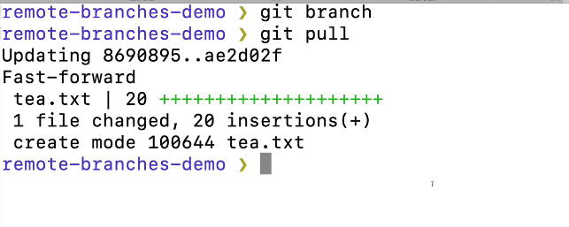

It pull the tea branch from origin.

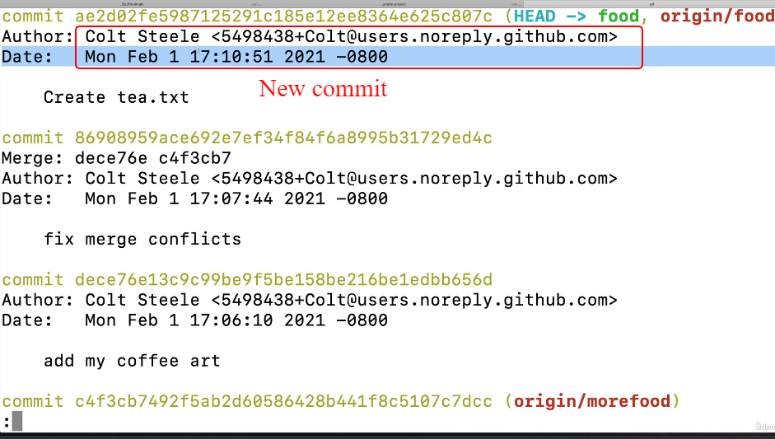

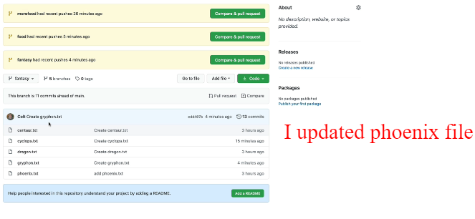

This is on gitup but not on local repo

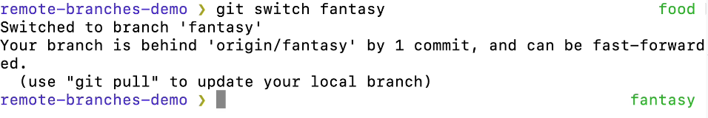

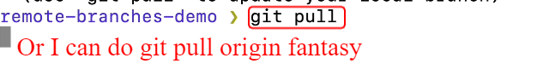

Anyone out of the 2 is fine.

If you have multiple remote you need to use the name.

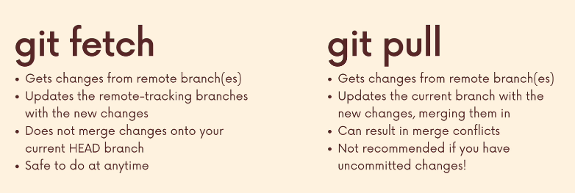

Pull is not recommended if you have uncommitted work.